Mineral Titles Act 2010
NOTICE OF LAND CEASING TO BE A MINERAL TITLE AREA
Title Type and Number: | Exploration Licence 30960
Area Ceased on: | 06 June 2022
Area: | 19 Blocks, 60.16 km²
Locality: | TOKO
Name of Applicant(s)/Holder(s): | 100% MLM DRILLING PTY LTD [ACN. 130 013 562]
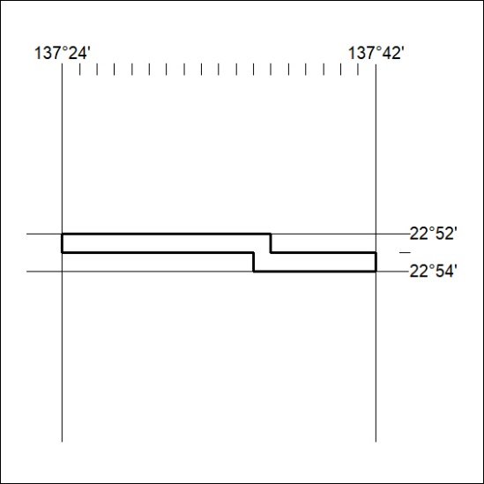

176/22

Mineral Titles Act
NOTICE OF GRANT OF A MINERAL TITLE
Title Type and Number: | Extractive Mineral Exploration Licence 32590
Granted: | 06 June 2022, for a period of 2 Years
Area: | 4 Blocks, 13.12 km²
Locality: | NEWCASTLE WATERS
Name of Holder/s: | 100% TERRITORY SANDS PTY LTD [ACN. 632 797 972]
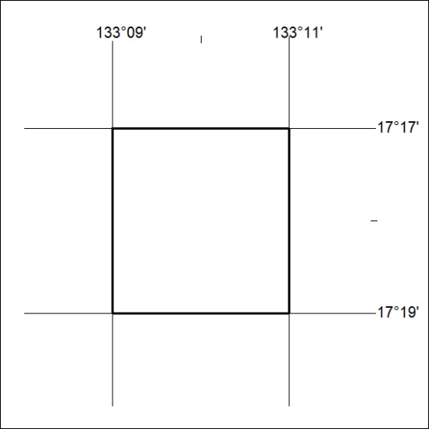
Area granted is indicated above. The titleholder is not permitted to exercise occupational rights on any land that is subject to a development title, or an application for a development title. Any land the subject of a Reserved Land gazettal under the Mineral Titles Act and all land vested in the Commonwealth of Australia is also excluded by description but not excised from the grant area.

177/22

Mineral Titles Act
NOTICE OF GRANT OF A MINERAL TITLE
Title Type and Number: | Extractive Mineral Exploration Licence 32591
Granted: | 06 June 2022, for a period of 2 Years
Area: | 4 Blocks, 13.12 km²
Locality: | NEWCASTLE WATERS
Name of Holder/s: | 100% TERRITORY SANDS PTY LTD [ACN. 632 797 972]
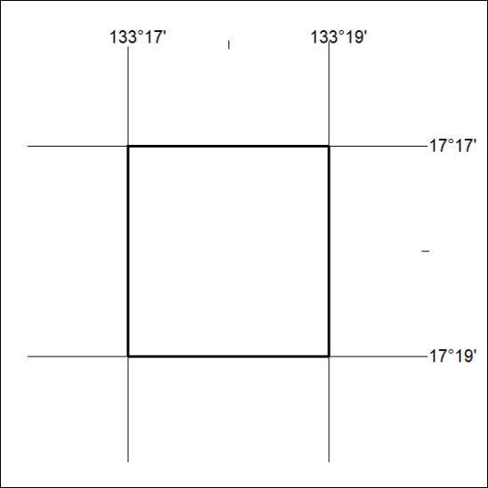
Area granted is indicated above. The titleholder is not permitted to exercise occupational rights on any land that is subject to a development title, or an application for a development title. Any land the subject of a Reserved Land gazettal under the Mineral Titles Act and all land vested in the Commonwealth of Australia is also excluded by description but not excised from the grant area.
178/22

Mineral Titles Act
NOTICE OF GRANT OF A MINERAL TITLE
Title Type and Number: | Extractive Mineral Exploration Licence 32592
Granted: | 06 June 2022, for a period of 2 Years
Area: | 4 Blocks, 13.11 km²
Locality: | NEWCASTLE WATERS
Name of Holder/s: | 100% TERRITORY SANDS PTY LTD [ACN. 632 797 972]
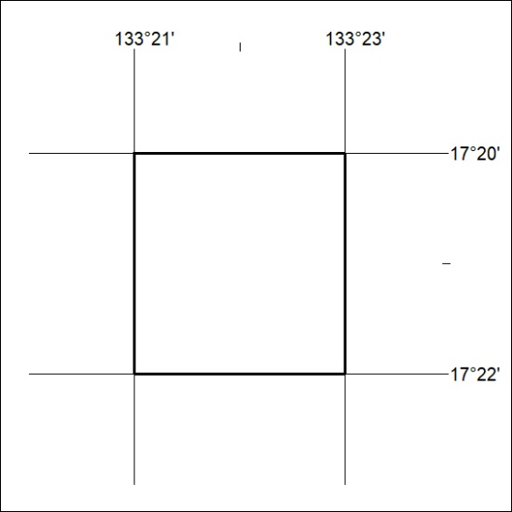
Area granted is indicated above. The titleholder is not permitted to exercise occupational rights on any land that is subject to a development title, or an application for a development title. Any land the subject of a Reserved Land gazettal under the Mineral Titles Act and all land vested in the Commonwealth of Australia is also excluded by description but not excised from the grant area.
179/22

Mineral Titles Act
NOTICE OF GRANT OF A MINERAL TITLE
Title Type and Number: | Extractive Mineral Exploration Licence 32595
Granted: | 06 June 2022, for a period of 2 Years
Area: | 4 Blocks, 13.24 km²
Locality: | LARRIMAH
Name of Holder/s: | 100% TERRITORY SANDS PTY LTD [ACN. 632 797 972]
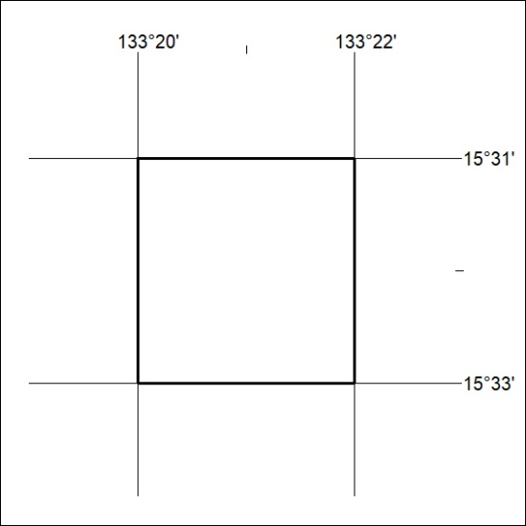
Area granted is indicated above. The titleholder is not permitted to exercise occupational rights on any land that is subject to a development title, or an application for a development title. Any land the subject of a Reserved Land gazettal under the Mineral Titles Act and all land vested in the Commonwealth of Australia is also excluded by description but not excised from the grant area.
180/22

Mineral Titles Act
NOTICE OF GRANT OF A MINERAL TITLE
Title Type and Number: | Extractive Mineral Exploration Licence 32596
Granted: | 06 June 2022, for a period of 2 Years
Area: | 4 Blocks, 13.24 km²
Locality: | LARRIMAH
Name of Holder/s: | 100% TERRITORY SANDS PTY LTD [ACN. 632 797 972]
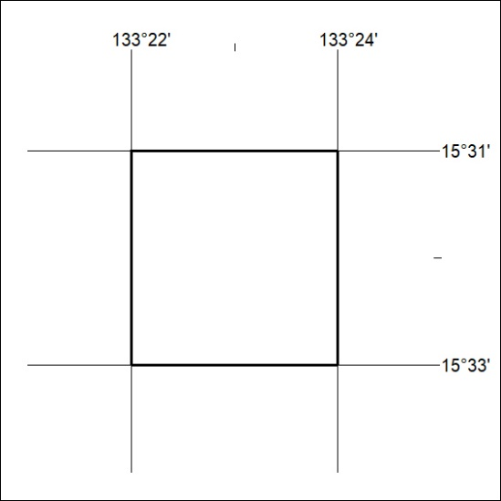
Area granted is indicated above. The titleholder is not permitted to exercise occupational rights on any land that is subject to a development title, or an application for a development title. Any land the subject of a Reserved Land gazettal under the Mineral Titles Act and all land vested in the Commonwealth of Australia is also excluded by description but not excised from the grant area.
181/22

Mineral Titles Act
NOTICE OF GRANT OF A MINERAL TITLE
Title Type and Number: | Extractive Mineral Exploration Licence 32609
Granted: | 06 June 2022, for a period of 2 Years
Area: | 4 Blocks, 13.12 km²
Locality: | NEWCASTLE WATERS
Name of Holder/s: | 100% TERRITORY SANDS PTY LTD [ACN. 632 797 972]
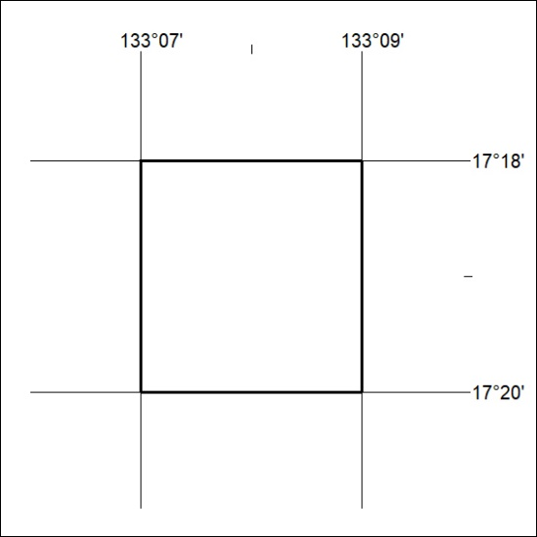
Area granted is indicated above. The titleholder is not permitted to exercise occupational rights on any land that is subject to a development title, or an application for a development title. Any land the subject of a Reserved Land gazettal under the Mineral Titles Act and all land vested in the Commonwealth of Australia is also excluded by description but not excised from the grant area.
182/22

Mineral Titles Act
NOTICE OF GRANT OF A MINERAL TITLE
Title Type and Number: | Exploration Licence 32974
Granted: | 06 June 2022, for a period of 6 Years
Area: | 248 Blocks, 769.60 km²
Locality: | EBENEZER
Name of Holder/s: | 100% CORE URANIUM PTY LTD [ACN. 652 691 579]
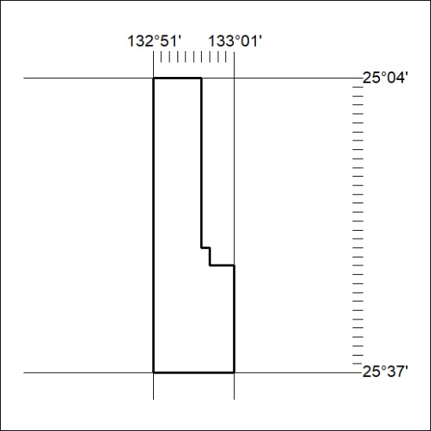
Area granted is indicated above. The titleholder is not permitted to exercise occupational rights on any land that is subject to a development title, or an application for a development title. Any land the subject of a Reserved Land gazettal under the Mineral Titles Act and all land vested in the Commonwealth of Australia is also excluded by description but not excised from the grant area.
183/22

Mineral Titles Act
NOTICE OF GRANT OF A MINERAL TITLE
Title Type and Number: | Exploration Licence 32975
Granted: | 06 June 2022, for a period of 6 Years
Area: | 250 Blocks, 776.64 km²
Locality: | ERLDUNDA
Name of Holder/s: | 100% CORE URANIUM PTY LTD [ACN. 652 691 579]
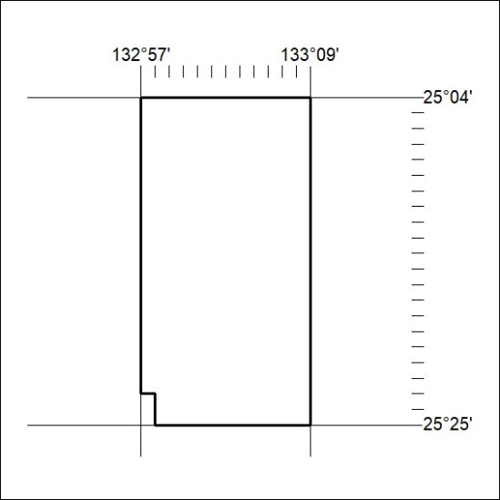
Area granted is indicated above. The titleholder is not permitted to exercise occupational rights on any land that is subject to a development title, or an application for a development title. Any land the subject of a Reserved Land gazettal under the Mineral Titles Act and all land vested in the Commonwealth of Australia is also excluded by description but not excised from the grant area.
184/22

Mineral Titles Act
NOTICE OF GRANT OF A MINERAL TITLE
Title Type and Number: | Exploration Licence 32976
Granted: | 06 June 2022, for a period of 6 Years
Area: | 241 Blocks, 748.67 km²
Locality: | ERLDUNDA
Name of Holder/s: | 100% CORE URANIUM PTY LTD [ACN. 652 691 579]
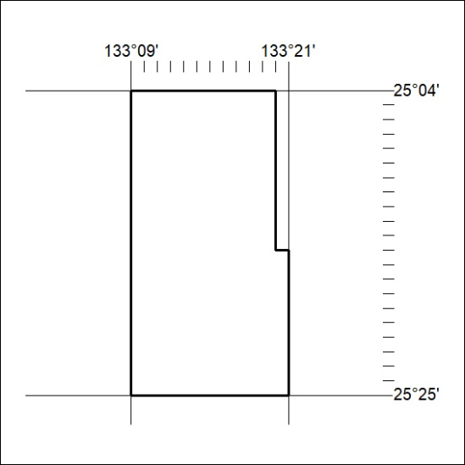
Area granted is indicated above. The titleholder is not permitted to exercise occupational rights on any land that is subject to a development title, or an application for a development title. Any land the subject of a Reserved Land gazettal under the Mineral Titles Act and all land vested in the Commonwealth of Australia is also excluded by description but not excised from the grant area.
185/22

Mineral Titles Act
NOTICE OF GRANT OF A MINERAL TITLE
Title Type and Number: | Exploration Licence 33014
Granted: | 06 June 2022, for a period of 6 Years
Area: | 198 Blocks, 633.86 km²
Locality: | WATERHOUSE
Name of Holder/s: | 100% CORE URANIUM PTY LTD [ACN. 652 691 579]
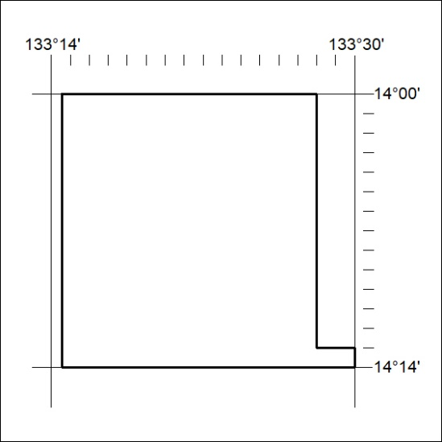
Area granted is indicated above. The titleholder is not permitted to exercise occupational rights on any land that is subject to a development title, or an application for a development title. Any land the subject of a Reserved Land gazettal under the Mineral Titles Act and all land vested in the Commonwealth of Australia is also excluded by description but not excised from the grant area.
186/22

