Mineral Titles Act
NOTICE OF GRANT OF A MINERAL TITLE
Title Type and Number: | Exploration Licence 32921
Granted: | 19 April 2022, for a period of 6 Years
Area: | 4 Blocks, 13.35 km²
Locality: | RANFORD HILL
Name of Holder/s: | 50% WOOD Sandra Maureen, 50% WOOD Gregory Lance
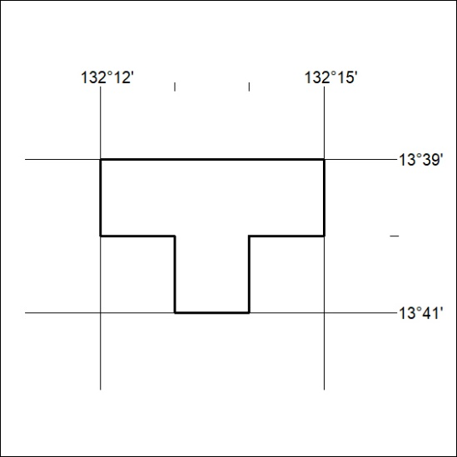
Area granted is indicated above. The titleholder is not permitted to exercise occupational rights on any land that is subject to a development title, or an application for a development title. Any land the subject of a Reserved Land gazettal under the Mineral Titles Act and all land vested in the Commonwealth of Australia is also excluded by description but not excised from the grant area.

117/22

Mineral Titles Act
NOTICE OF GRANT OF A MINERAL TITLE
Title Type and Number: | Mineral Lease 32704
Granted: | 25 March 2022, for a period of 30 Years
Area: | 1444.00 Hectares
Locality: | LANGDON
Name of Holder/s: | 100% WINCHELSEA MINING PTY LTD [ACN. 626 747 037]
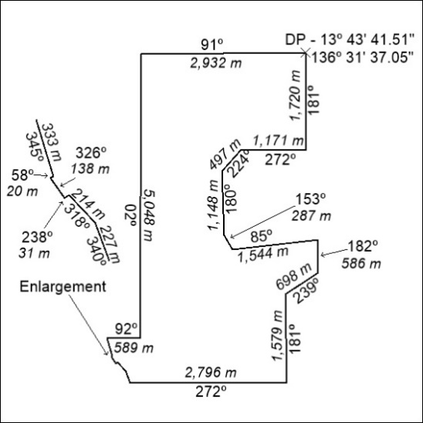

118/22

