Mineral Titles Act
NOTICE OF GRANT OF A MINERAL TITLE
Title Type and Number: | Exploration Licence 32881
Granted: | 01 April 2022, for a period of 6 Years
Area: | 208 Blocks, 680.25 km²
Locality: | COANJULA
Name of Holder/s: | 100% GSW RESOURCES PTY LTD [ACN. 653 791 130]
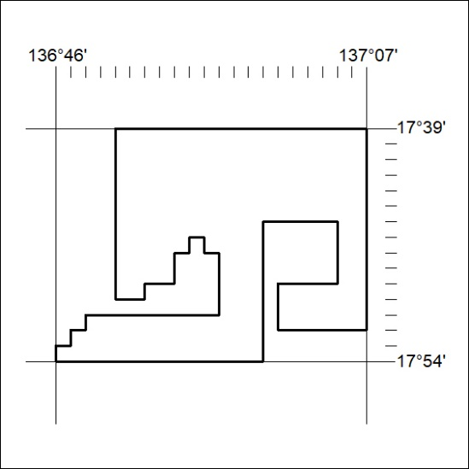
Area granted is indicated above. The titleholder is not permitted to exercise occupational rights on any land that is subject to a development title, or an application for a development title. Any land the subject of a Reserved Land gazettal under the Mineral Titles Act and all land vested in the Commonwealth of Australia is also excluded by description but not excised from the grant area.
84/22

Mineral Titles Act
NOTICE OF GRANT OF A MINERAL TITLE
Title Type and Number: | Exploration Licence 32882
Granted: | 01 April 2022, for a period of 6 Years
Area: | 217 Blocks, 708.39 km²
Locality: | PARADISE BORE
Name of Holder/s: | 100% GSW RESOURCES PTY LTD [ACN. 653 791 130]
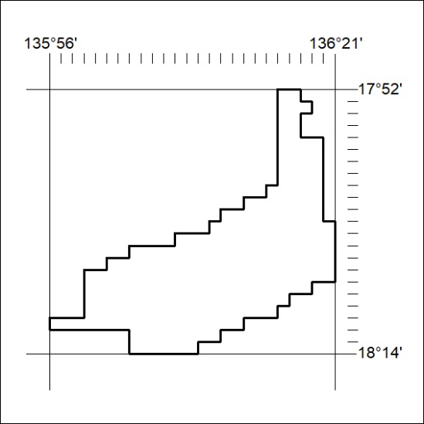
Area granted is indicated above. The titleholder is not permitted to exercise occupational rights on any land that is subject to a development title, or an application for a development title. Any land the subject of a Reserved Land gazettal under the Mineral Titles Act and all land vested in the Commonwealth of Australia is also excluded by description but not excised from the grant area.
85/22

