Mineral Titles Act 2010
NOTICE OF LAND CEASING TO BE A MINERAL TITLE AREA
Title Type and Number: | Extractive Mineral Exploration Licence 32193
Area Ceased on: | 20 February 2022
Area: | 1 Block, 2.58 km²
Locality: | BYNOE
Name of Applicant(s)/Holder(s): | 100% ALLAN KING & SONS CONSTRUCTION PTY LTD [ACN. 068 688 148]
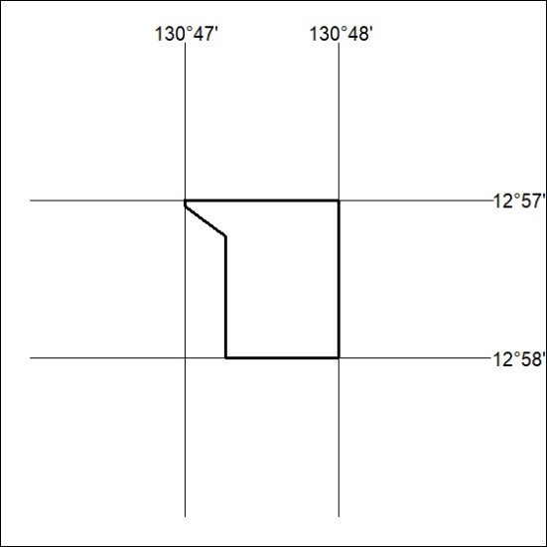

32/22

Mineral Titles Act
NOTICE OF GRANT OF A MINERAL TITLE
Title Type and Number: | Exploration Licence 32796
Granted: | 21 February 2022, for a period of 6 Years
Area: | 250 Blocks, 765.39 km²
Locality: | SEYMOUR
Name of Holder/s: | 100% TOMORROW MINERALS PTY LTD [ACN. 651 834 641]
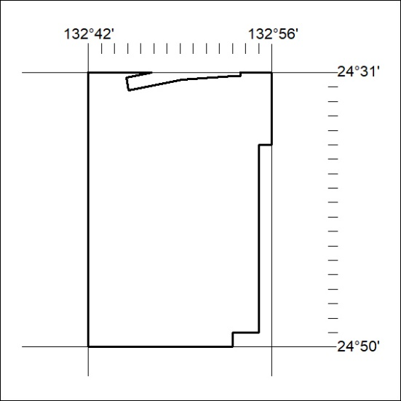
Area granted is indicated above. The titleholder is not permitted to exercise occupational rights on any land that is subject to a development title, or an application for a development title. Any land the subject of a Reserved Land gazettal under the Mineral Titles Act and all land vested in the Commonwealth of Australia is also excluded by description but not excised from the grant area.
33/22

Mineral Titles Act
NOTICE OF GRANT OF A MINERAL TITLE
Title Type and Number: | Exploration Licence 32797
Granted: | 21 February 2022, for a period of 6 Years
Area: | 250 Blocks, 776.55 km²
Locality: | HENBURY
Name of Holder/s: | 100% TOMORROW MINERALS PTY LTD [ACN. 651 834 641]
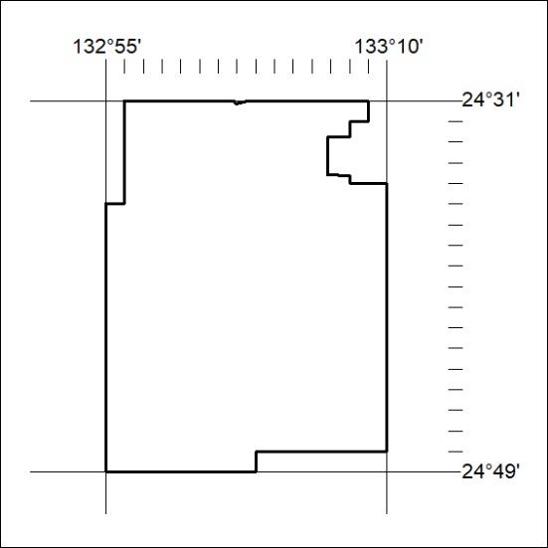
Area granted is indicated above. The titleholder is not permitted to exercise occupational rights on any land that is subject to a development title, or an application for a development title. Any land the subject of a Reserved Land gazettal under the Mineral Titles Act and all land vested in the Commonwealth of Australia is also excluded by description but not excised from the grant area.
34/22

Mineral Titles Act
NOTICE OF GRANT OF A MINERAL TITLE
Title Type and Number: | Exploration Licence 32798
Granted: | 21 February 2022, for a period of 6 Years
Area: | 250 Blocks, 779.05 km²
Locality: | HENBURY
Name of Holder/s: | 100% TOMORROW MINERALS PTY LTD [ACN. 651 834 641]
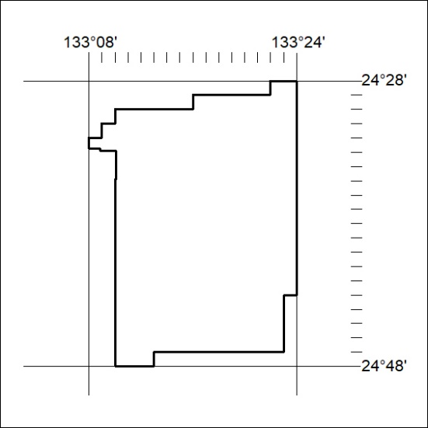
Area granted is indicated above. The titleholder is not permitted to exercise occupational rights on any land that is subject to a development title, or an application for a development title. Any land the subject of a Reserved Land gazettal under the Mineral Titles Act and all land vested in the Commonwealth of Australia is also excluded by description but not excised from the grant area.
35/22

Mineral Titles Act
NOTICE OF GRANT OF A MINERAL TITLE
Title Type and Number: | Exploration Licence 32799
Granted: | 21 February 2022, for a period of 6 Years
Area: | 250 Blocks, 777.40 km²
Locality: | CHARLOTTE
Name of Holder/s: | 100% TOMORROW MINERALS PTY LTD [ACN. 651 834 641]
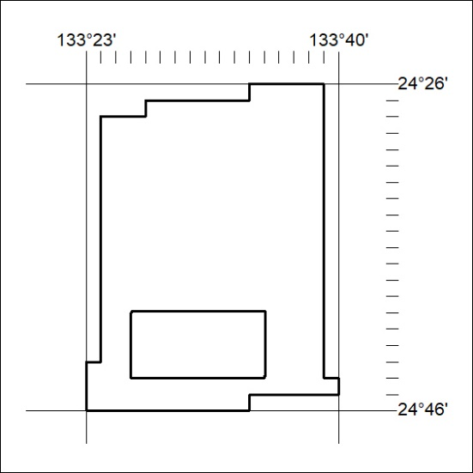
Area granted is indicated above. The titleholder is not permitted to exercise occupational rights on any land that is subject to a development title, or an application for a development title. Any land the subject of a Reserved Land gazettal under the Mineral Titles Act and all land vested in the Commonwealth of Australia is also excluded by description but not excised from the grant area.
36/22

Mineral Titles Act
NOTICE OF GRANT OF A MINERAL TITLE
Title Type and Number: | Exploration Licence 32800
Granted: | 21 February 2022, for a period of 6 Years
Area: | 250 Blocks, 779.81 km²
Locality: | CHARLOTTE
Name of Holder/s: | 100% TOMORROW MINERALS PTY LTD [ACN. 651 834 641]
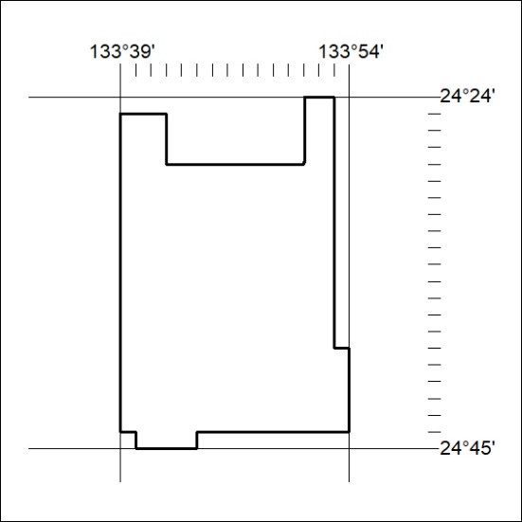
Area granted is indicated above. The titleholder is not permitted to exercise occupational rights on any land that is subject to a development title, or an application for a development title. Any land the subject of a Reserved Land gazettal under the Mineral Titles Act and all land vested in the Commonwealth of Australia is also excluded by description but not excised from the grant area.
37/22

Mineral Titles Act
NOTICE OF GRANT OF A MINERAL TITLE
Title Type and Number: | Exploration Licence 32801
Granted: | 21 February 2022, for a period of 6 Years
Area: | 250 Blocks, 777.09 km²
Locality: | CHARLOTTE
Name of Holder/s: | 100% TOMORROW MINERALS PTY LTD [ACN. 651 834 641]
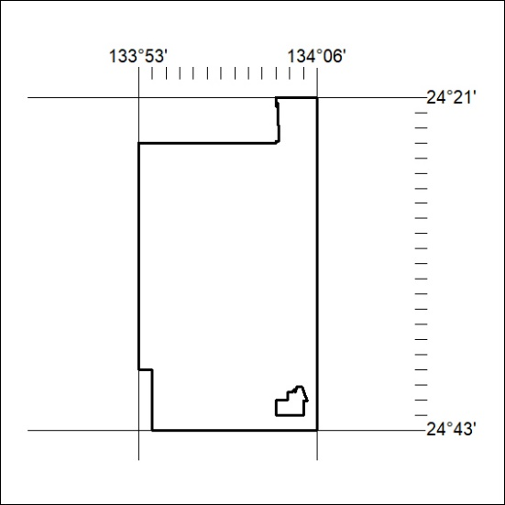
Area granted is indicated above. The titleholder is not permitted to exercise occupational rights on any land that is subject to a development title, or an application for a development title. Any land the subject of a Reserved Land gazettal under the Mineral Titles Act and all land vested in the Commonwealth of Australia is also excluded by description but not excised from the grant area.
38/22

Mineral Titles Act
NOTICE OF GRANT OF A MINERAL TITLE
Title Type and Number: | Exploration Licence 32802
Granted: | 21 February 2022, for a period of 6 Years
Area: | 250 Blocks, 781.24 km²
Locality: | SANTA TERESA
Name of Holder/s: | 100% TOMORROW MINERALS PTY LTD [ACN. 651 834 641]
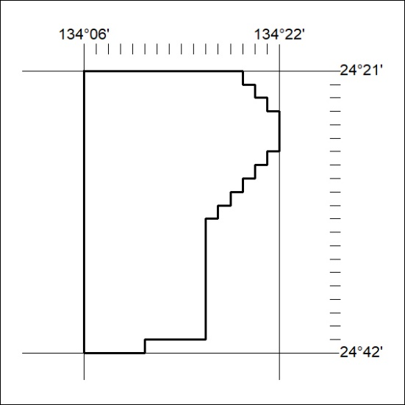
Area granted is indicated above. The titleholder is not permitted to exercise occupational rights on any land that is subject to a development title, or an application for a development title. Any land the subject of a Reserved Land gazettal under the Mineral Titles Act and all land vested in the Commonwealth of Australia is also excluded by description but not excised from the grant area.
39/22
Corrigendum
Notice Number 25/22 appearing in MN09/22 on 10 February 2022 is hereby cancelled and replaced by the following:

Mineral Titles Act 2010
NOTICE OF LAND CEASING TO BE A MINERAL TITLE AREA
Title Type and Number: | Extractive Mineral Lease 30443
Area ceased on: | 18 February 2022
Area: | 3.00 Hectare
Locality: | MALLAPUNYAH
Name of Applicants(s)Holder(s): | 100% SCHILLING Christopher Llewellyn
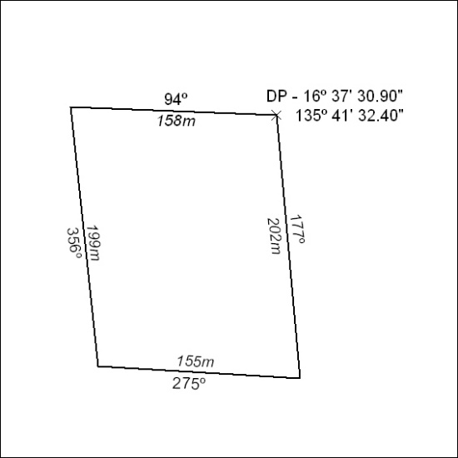

40/22

