Mineral Titles Act 2010
NOTICE OF LAND CEASING TO BE A MINERAL TITLE AREA
Title Type and Number: | Extractive Mineral Exploration Licence 32192
Area Ceased on: | 16 February 2022
Area: | 3 Blocks, 2.91 km²
Locality: | NOONAMAH
Name of Applicant(s)/Holder(s): | 100% DARWIN RIVER QUARRIES PTY LTD [ACN. 167 335 882]
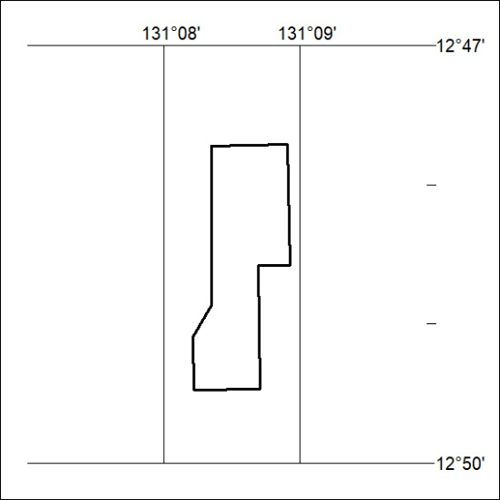

29/22

Mineral Titles Act 2010
NOTICE OF LAND CEASING TO BE A MINERAL TITLE AREA
Title Type and Number: | Extractive Mineral Exploration Licence 32194
Area Ceased on: | 16 February 2022
Area: | 2 Blocks, 1.72 km²
Locality: | NOONAMAH
Name of Applicant(s)/Holder(s): | 100% ALDEBARAN CONTRACTING PTY LTD [ACN. 128 020 299]
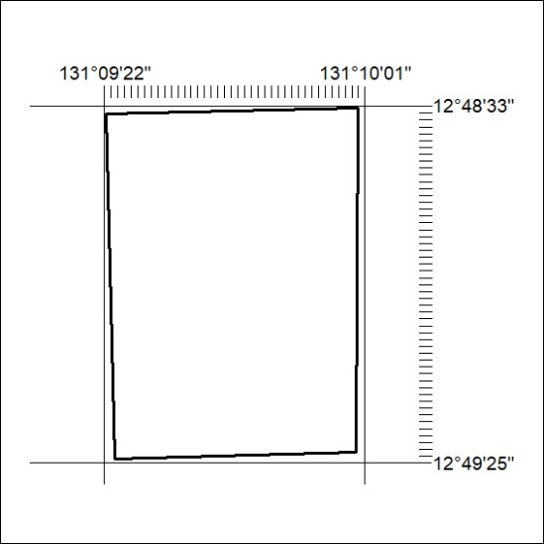

30/22

Mineral Titles Act
NOTICE OF GRANT OF A MINERAL TITLE
Title Type and Number: | Exploration Licence 32813
Granted: | 17 February 2022, for a period of 6 Years
Area: | 7 Blocks, 22.72 km²
Locality: | GALLIPOLI
Name of Holder/s: | 100% BAUDIN RESOURCES PTY LTD [ACN. 618 455 593]
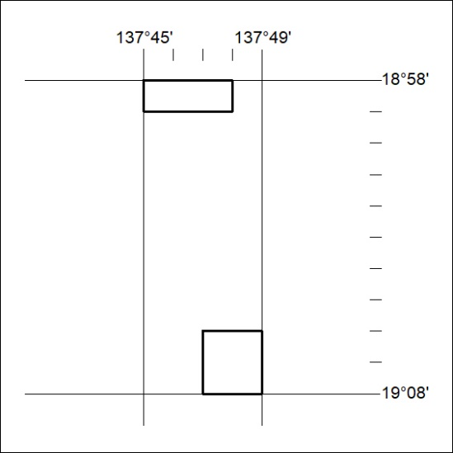
Area granted is indicated above. The titleholder is not permitted to exercise occupational rights on any land that is subject to a development title, or an application for a development title. Any land the subject of a Reserved Land gazettal under the Mineral Titles Act and all land vested in the Commonwealth of Australia is also excluded by description but not excised from the grant area.

31/22

