Mineral Titles Act 2010
NOTICE OF LAND CEASING TO BE A MINERAL TITLE AREA
Title Type and Number: | Extractive Mineral Permit 31231
Area ceased on: | 17 January 2022
Area: | 11.00 Hectare
Locality: | NOONAMAH
Name of Applicants(s)Holder(s): | 100% CHAMBERS Kenneth John
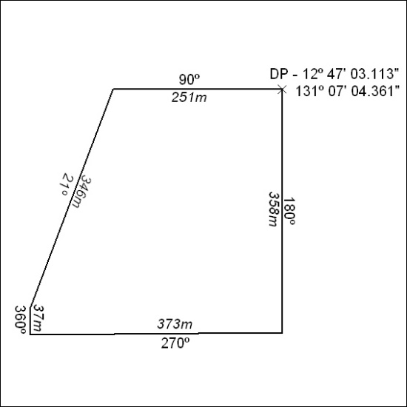

015/22

