Mineral Titles Act
NOTICE OF GRANT OF A MINERAL TITLE
Title Type and Number: | Exploration Licence 32476
Granted: | 20 September 2021, for a period of 6 Years
Area: | 248 Blocks, 805.42 km²
Locality: | CARRARA
Name of Holder/s: | 100% BAUDIN RESOURCES PTY LTD [ACN. 618 455 593]
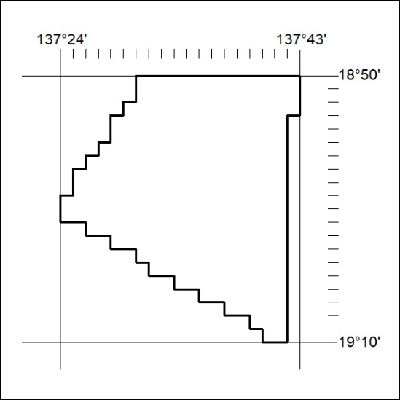
Area granted is indicated above. The titleholder is not permitted to exercise occupational rights on any land that is subject to a development title, or an application for a development title. Any land the subject of a Reserved Land gazettal under the Mineral Titles Act and all land vested in the Commonwealth of Australia is also excluded by description but not excised from the grant area.
356/21

Mineral Titles Act
NOTICE OF GRANT OF A MINERAL TITLE
Title Type and Number: | Exploration Licence 32477
Granted: | 20 September 2021, for a period of 6 Years
Area: | 248 Blocks, 805.21 km²
Locality: | GALLIPOLI
Name of Holder/s: | 100% BAUDIN RESOURCES PTY LTD [ACN. 618 455 593]
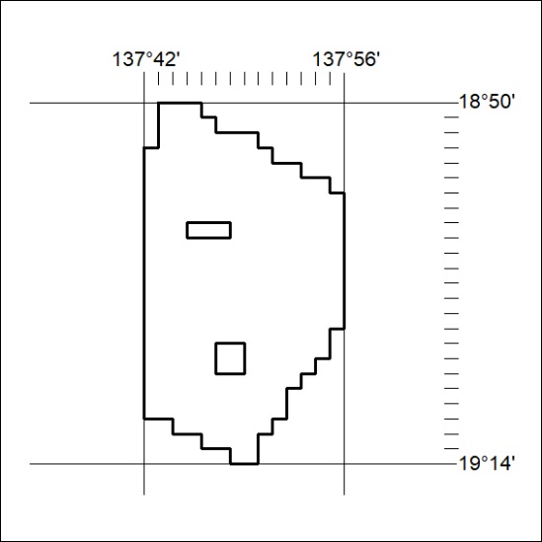
Area granted is indicated above. The titleholder is not permitted to exercise occupational rights on any land that is subject to a development title, or an application for a development title. Any land the subject of a Reserved Land gazettal under the Mineral Titles Act and all land vested in the Commonwealth of Australia is also excluded by description but not excised from the grant area.
357/21

