Mineral Titles Act 2010
NOTICE OF LAND CEASING TO BE A MINERAL TITLE APPLICATION AREA
Title Type and Number: | Extractive Mineral Lease 32025
Area ceased on: | 26 July 2021
Area: | 99.00 Hectare
Locality: | JERVOIS RANGE
Name of Applicants(s)Holder(s): | 100% JINKA MINERALS LIMITED [ACN. 131 851 404]
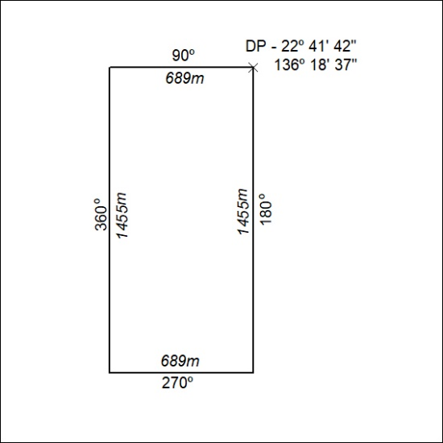

276/21

