Mineral Titles Act 2010
NOTICE OF LAND CEASING TO BE A MINERAL TITLE AREA
Title Type and Number: | Extractive Mineral Exploration Licence 31969
Area Ceased on: | 22 April 2021
Area: | 3 Blocks, 2.30 km²
Locality: | KOOLPINYAH
Name of Applicant(s)/Holder(s): | 100% MOUSELLIS & SONS PTY. LTD. [ACN. 009 654 791]
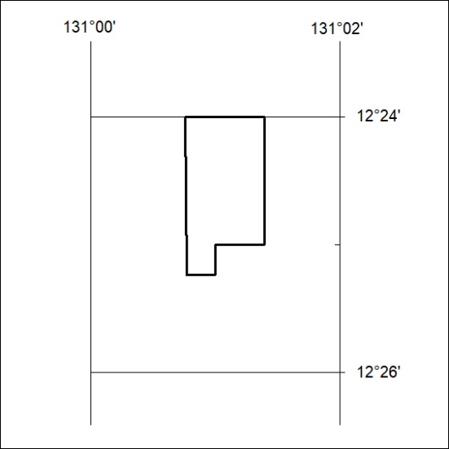

108/21

Mineral Titles Act 2010
NOTICE OF LAND CEASING TO BE A MINERAL TITLE AREA
Title Type and Number: | Extractive Mineral Exploration Licence 31970
Area Ceased on: | 22 April 2021
Area: | 2 Blocks, .66 km²
Locality: | KOOLPINYAH
Name of Applicant(s)/Holder(s): | 100% MOUSELLIS & SONS PTY. LTD. [ACN. 009 654 791]
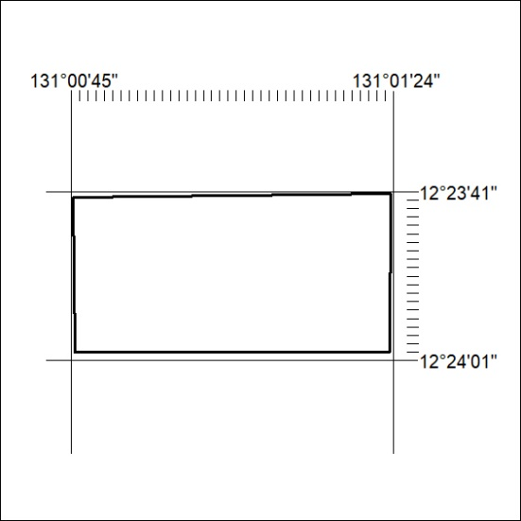

109/21

Mineral Titles Act
NOTICE OF GRANT OF A MINERAL TITLE
Title Type and Number: | Exploration Licence 32418
Granted: | 22 April 2021, for a period of 6 Years
Area: | 41 Blocks, 134.98 km²
Locality: | RANFORD HILL
Name of Holder/s: | 100% TRAFALGAR RESOURCES PTY LTD [ACN. 612 053 166]
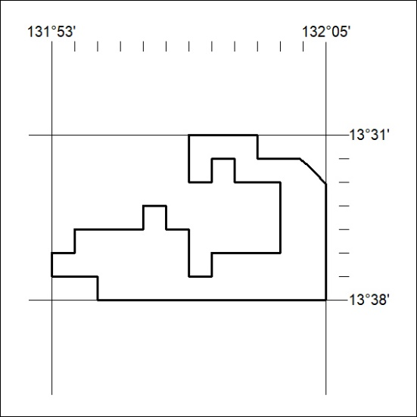
Area granted is indicated above. The titleholder is not permitted to exercise occupational rights on any land that is subject to a development title, or an application for a development title. Any land the subject of a Reserved Land gazettal under the Mineral Titles Act and all land vested in the Commonwealth of Australia is also excluded by description but not excised from the grant area.

110/21

