Mineral Titles Act 2010
NOTICE OF LAND CEASING TO BE A MINERAL TITLE AREA
Title Type and Number: | Extractive Mineral Permit 29709
Area ceased on: | 10 April 2021
Area: | 37.00 Hectare
Locality: | KOOLPINYAH
Name of Applicants(s)Holder(s): | 100% TOMAZOS GROUP PTY LTD [ACN. 009 618 704]
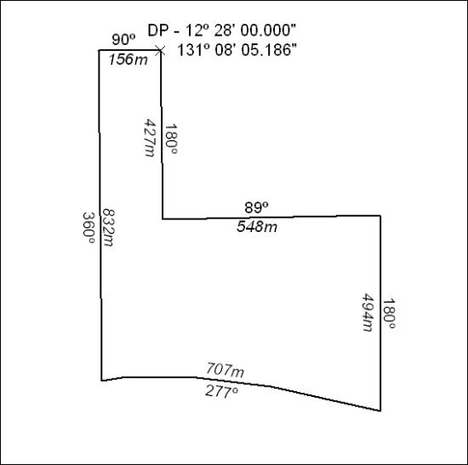

78/21

Mineral Titles Act
NOTICE OF GRANT OF A MINERAL TITLE
Title Type and Number: | Mineral Lease 32214
Granted: | 07 April 2021, for a period of 20 Years
Area: | 72.05 Hectares
Locality: | TENNANT CREEK
Name of Holder/s: | 100% GIANTS REEF EXPLORATION PTY LTD* [ACN. 009 200 346]
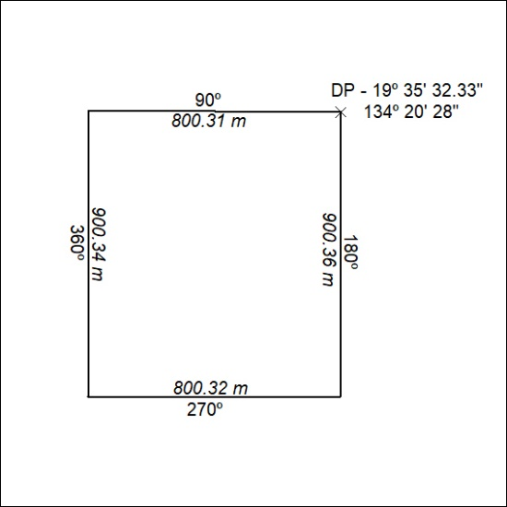

79/21

