Mineral Titles Act
NOTICE OF GRANT OF A MINERAL TITLE
Title Type and Number: | Exploration Licence 32190
Granted: | 30 March 2021, for a period of 6 Years
Area: | 82 Blocks, 248.63 km²
Locality: | RIDDOCH
Name of Holder/s: | 100% KALK EXPLORATION PTY LTD [ACN. 634 749 429]
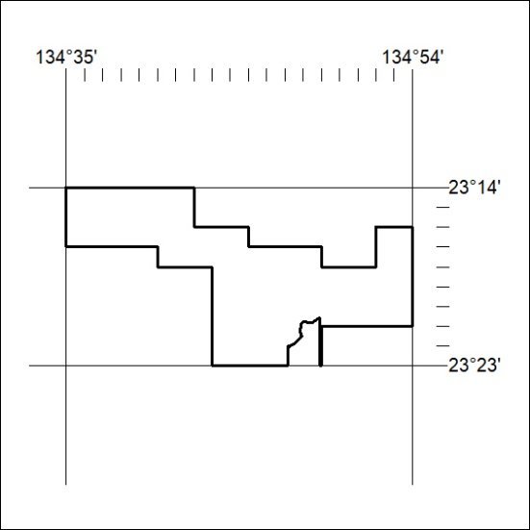
Area granted is indicated above. The titleholder is not permitted to exercise occupational rights on any land that is subject to a development title, or an application for a development title. Any land the subject of a Reserved Land gazettal under the Mineral Titles Act and all land vested in the Commonwealth of Australia is also excluded by description but not excised from the grant area.
65/21

Mineral Titles Act
NOTICE OF GRANT OF A MINERAL TITLE
Title Type and Number: | Exploration Licence 32464
Granted: | 30 March 2021, for a period of 6 Years
Area: | 219 Blocks, 706.23 km²
Locality: | BORROLOOLA
Name of Holder/s: | 100% REDBANK OPERATIONS PTY LTD* [ACN. 109 362 165]
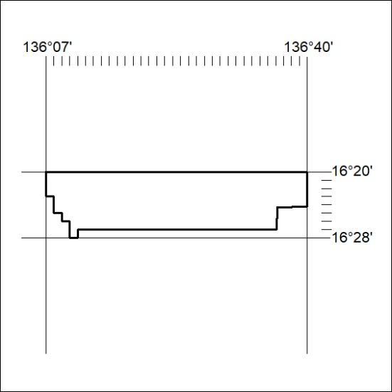
Area granted is indicated above. The titleholder is not permitted to exercise occupational rights on any land that is subject to a development title, or an application for a development title. Any land the subject of a Reserved Land gazettal under the Mineral Titles Act and all land vested in the Commonwealth of Australia is also excluded by description but not excised from the grant area.
66/21

Mineral Titles Act
NOTICE OF GRANT OF A MINERAL TITLE
Title Type and Number: | Exploration Licence 32465
Granted: | 30 March 2021, for a period of 6 Years
Area: | 247 Blocks, 784.86 km²
Locality: | GLYDE
Name of Holder/s: | 100% REDBANK OPERATIONS PTY LTD* [ACN. 109 362 165]
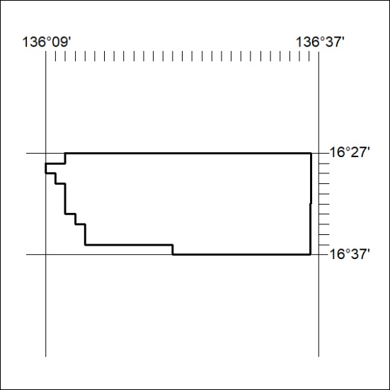
Area granted is indicated above. The titleholder is not permitted to exercise occupational rights on any land that is subject to a development title, or an application for a development title. Any land the subject of a Reserved Land gazettal under the Mineral Titles Act and all land vested in the Commonwealth of Australia is also excluded by description but not excised from the grant area.
67/21

Mineral Titles Act
NOTICE OF GRANT OF A MINERAL TITLE
Title Type and Number: | Exploration Licence 32466
Granted: | 30 March 2021, for a period of 6 Years
Area: | 250 Blocks, 778.31 km²
Locality: | GLYDE
Name of Holder/s: | 100% REDBANK OPERATIONS PTY LTD* [ACN. 109 362 165]
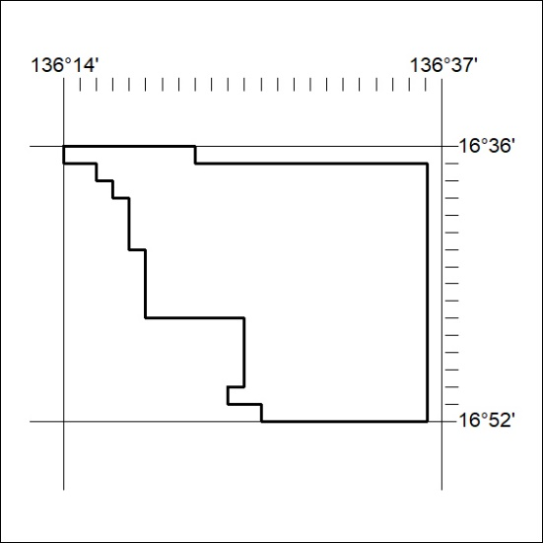
Area granted is indicated above. The titleholder is not permitted to exercise occupational rights on any land that is subject to a development title, or an application for a development title. Any land the subject of a Reserved Land gazettal under the Mineral Titles Act and all land vested in the Commonwealth of Australia is also excluded by description but not excised from the grant area.
67/21

Mineral Titles Act
NOTICE OF GRANT OF A MINERAL TITLE
Title Type and Number: | Exploration Licence 32467
Granted: | 30 March 2021, for a period of 6 Years
Area: | 250 Blocks, 797.48 km²
Locality: | LANCEWOOD
Name of Holder/s: | 100% REDBANK OPERATIONS PTY LTD* [ACN. 109 362 165]
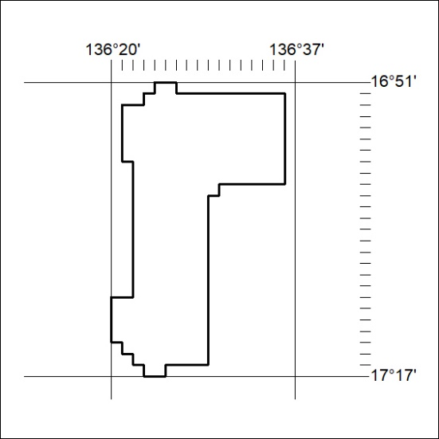
Area granted is indicated above. The titleholder is not permitted to exercise occupational rights on any land that is subject to a development title, or an application for a development title. Any land the subject of a Reserved Land gazettal under the Mineral Titles Act and all land vested in the Commonwealth of Australia is also excluded by description but not excised from the grant area.
68/21

Mineral Titles Act
NOTICE OF GRANT OF A MINERAL TITLE
Title Type and Number: | Exploration Licence 32469
Granted: | 30 March 2021, for a period of 6 Years
Area: | 250 Blocks, 788.73 km²
Locality: | CALVERT HILLS
Name of Holder/s: | 100% REDBANK OPERATIONS PTY LTD* [ACN. 109 362 165]
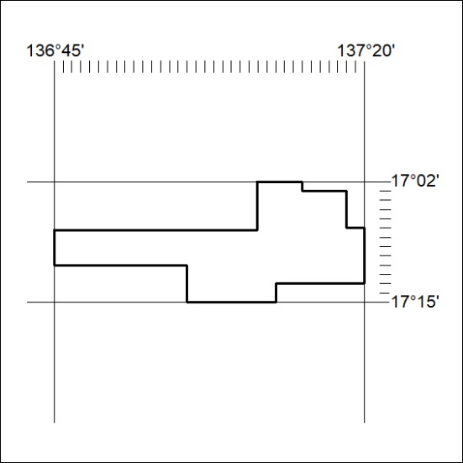
Area granted is indicated above. The titleholder is not permitted to exercise occupational rights on any land that is subject to a development title, or an application for a development title. Any land the subject of a Reserved Land gazettal under the Mineral Titles Act and all land vested in the Commonwealth of Australia is also excluded by description but not excised from the grant area.
69/21

Mineral Titles Act
NOTICE OF GRANT OF A MINERAL TITLE
Title Type and Number: | Exploration Licence 32470
Granted: | 30 March 2021, for a period of 6 Years
Area: | 183 Blocks, 574.37 km²
Locality: | SURPRISE CREEK
Name of Holder/s: | 100% REDBANK OPERATIONS PTY LTD* [ACN. 109 362 165]
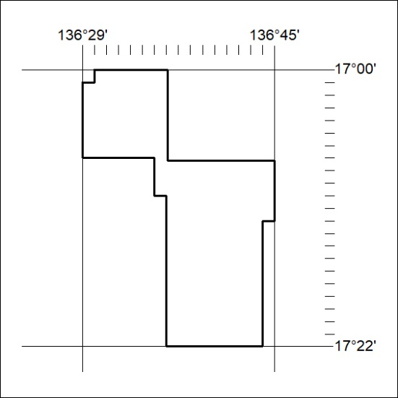
Area granted is indicated above. The titleholder is not permitted to exercise occupational rights on any land that is subject to a development title, or an application for a development title. Any land the subject of a Reserved Land gazettal under the Mineral Titles Act and all land vested in the Commonwealth of Australia is also excluded by description but not excised from the grant area.
70/21

Mineral Titles Act
NOTICE OF GRANT OF A MINERAL TITLE
Title Type and Number: | Exploration Licence 32471
Granted: | 30 March 2021, for a period of 6 Years
Area: | 70 Blocks, 229.57 km²
Locality: | CALVERT HILLS
Name of Holder/s: | 100% REDBANK OPERATIONS PTY LTD* [ACN. 109 362 165]
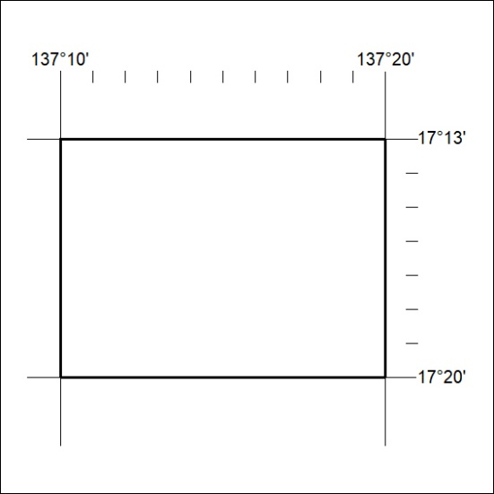
Area granted is indicated above. The titleholder is not permitted to exercise occupational rights on any land that is subject to a development title, or an application for a development title. Any land the subject of a Reserved Land gazettal under the Mineral Titles Act and all land vested in the Commonwealth of Australia is also excluded by description but not excised from the grant area.
71/21

