Mineral Titles Act 2010
NOTICE OF LAND CEASING TO BE A MINERAL TITLE APPLICATION AREA
Title Type and Number: | Exploration Licence 32565
Area Ceased on: | 22 March 2021
Area: | 250 Blocks, 769.35 km²
Locality: | MACDONNELL RANGES
Name of Applicant(s)/Holder(s): | 100% GEMPART (NT) PTY LTD* [ACN. 081 859 896]
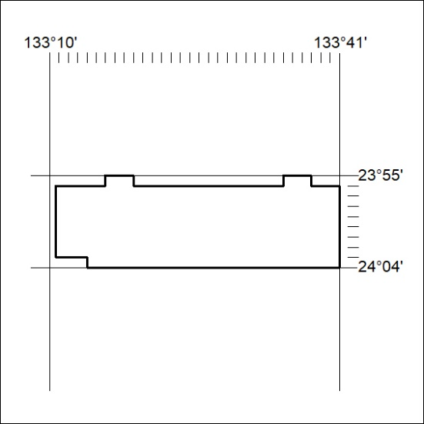

54/21

