Mineral Titles Act
NOTICE OF GRANT OF A MINERAL TITLE
Title Type and Number: | Exploration Licence 32299
Granted: | 04 February 2021, for a period of 6 Years
Area: | 60 Blocks, 194.43 km²
Locality: | ALROY
Name of Holder/s: | 100% NEWCREST OPERATIONS LIMITED [ACN. 009 221 505]
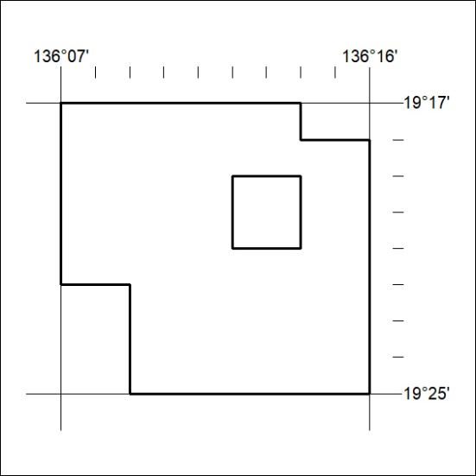
Area granted is indicated above. The titleholder is not permitted to exercise occupational rights on any land that is subject to a development title, or an application for a development title. Any land the subject of a Reserved Land gazettal under the Mineral Titles Act and all land vested in the Commonwealth of Australia is also excluded by description but not excised from the grant area.
29/21

Mineral Titles Act
NOTICE OF GRANT OF A MINERAL TITLE
Title Type and Number: | Exploration Licence 32300
Granted: | 04 February 2021, for a period of 6 Years
Area: | 80 Blocks, 259.44 km²
Locality: | ALROY
Name of Holder/s: | 100% NEWCREST OPERATIONS LIMITED [ACN. 009 221 505]
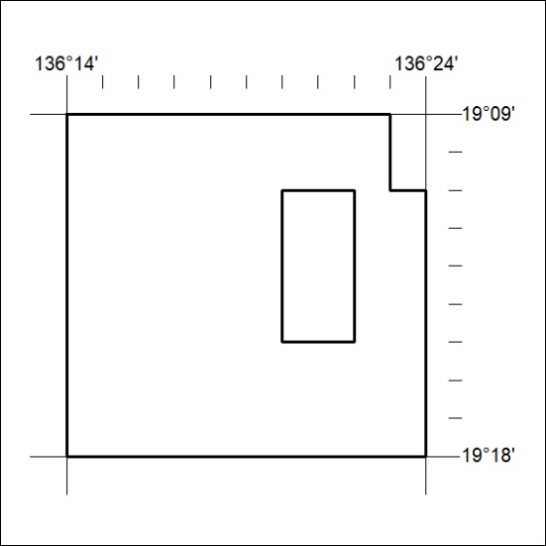
Area granted is indicated above. The titleholder is not permitted to exercise occupational rights on any land that is subject to a development title, or an application for a development title. Any land the subject of a Reserved Land gazettal under the Mineral Titles Act and all land vested in the Commonwealth of Australia is also excluded by description but not excised from the grant area.
30/21

Mineral Titles Act
NOTICE OF GRANT OF A MINERAL TITLE
Title Type and Number: | Exploration Licence 32302
Granted: | 04 February 2021, for a period of 6 Years
Area: | 120 Blocks, 387.90 km²
Locality: | WONARAH
Name of Holder/s: | 100% NEWCREST OPERATIONS LIMITED [ACN. 009 221 505]
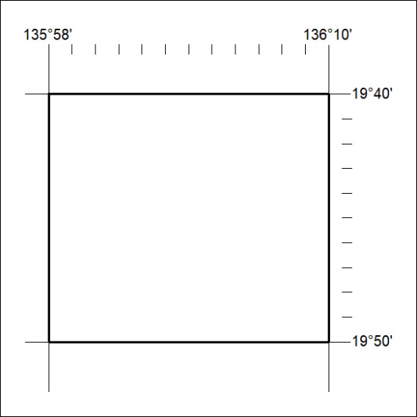
Area granted is indicated above. The titleholder is not permitted to exercise occupational rights on any land that is subject to a development title, or an application for a development title. Any land the subject of a Reserved Land gazettal under the Mineral Titles Act and all land vested in the Commonwealth of Australia is also excluded by description but not excised from the grant area.
31/21

Mineral Titles Act
NOTICE OF GRANT OF A MINERAL TITLE
Title Type and Number: | Exploration Licence 32303
Granted: | 04 February 2021, for a period of 6 Years
Area: | 151 Blocks, 488.70 km²
Locality: | DALMORE
Name of Holder/s: | 100% NEWCREST OPERATIONS LIMITED [ACN. 009 221 505]
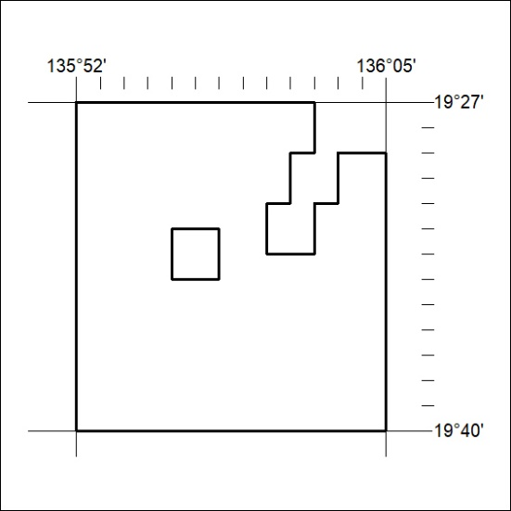
Area granted is indicated above. The titleholder is not permitted to exercise occupational rights on any land that is subject to a development title, or an application for a development title. Any land the subject of a Reserved Land gazettal under the Mineral Titles Act and all land vested in the Commonwealth of Australia is also excluded by description but not excised from the grant area.
32/21

