Mineral Titles Act 2010
NOTICE OF LAND CEASING TO BE A MINERAL TITLE APPLICATION AREA
Title Type and Number: | Exploration Licence 26191
Area Ceased on: | 03 December 2020
Area: | 434 Blocks, 1364.19 km²
Locality: | YINGURRDU
Name of Applicant(s)/Holder(s): | 100% QUASAR RESOURCES PTY. LTD. [ACN. 101 227 070]
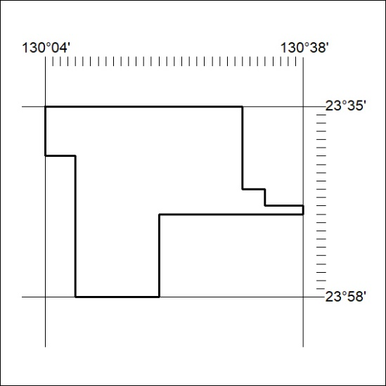
394/20

Mineral Titles Act 2010
NOTICE OF LAND CEASING TO BE A MINERAL TITLE APPLICATION AREA
Title Type and Number: | Exploration Licence 26192
Area Ceased on: | 03 December 2020
Area: | 278 Blocks, 873.97 km²
Locality: | RENNIE
Name of Applicant(s)/Holder(s): | 100% QUASAR RESOURCES PTY. LTD. [ACN. 101 227 070]
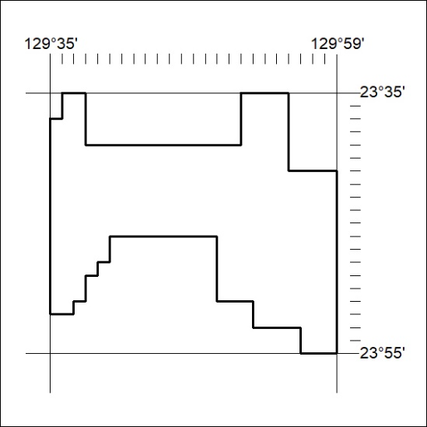
395/20

Mineral Titles Act 2010
NOTICE OF LAND CEASING TO BE A MINERAL TITLE AREA
Title Type and Number: | Extractive Mineral Exploration Licence 31920
Area Ceased on: | 04 December 2020
Area: | 4 Blocks, 8.56 km²
Locality: | MARY RIVER
Name of Applicant(s)/Holder(s): | 100% MT ROMANCE (NT) PTY LTD [ACN. 623 930 594]
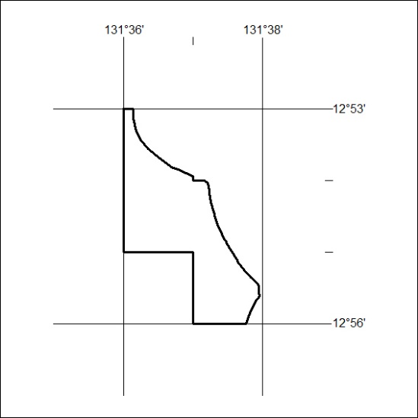
396/20

Mineral Titles Act 2010
NOTICE OF LAND CEASING TO BE A MINERAL TITLE AREA
Title Type and Number: | Extractive Mineral Exploration Licence 31921
Area Ceased on: | 04 December 2020
Area: | 4 Blocks, 13.39 km²
Locality: | MARY RIVER
Name of Applicant(s)/Holder(s): | 100% MT ROMANCE (NT) PTY LTD [ACN. 623 930 594]
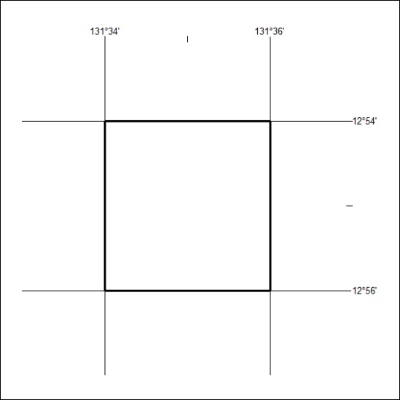
397/20

Mineral Titles Act 2010
NOTICE OF LAND CEASING TO BE A MINERAL TITLE AREA
Title Type and Number: | Extractive Mineral Exploration Licence 31922
Area Ceased on: | 04 December 2020
Area: | 4 Blocks, 12.44 km²
Locality: | MARY RIVER
Name of Applicant(s)/Holder(s): | 100% MT ROMANCE (NT) PTY LTD [ACN. 623 930 594]
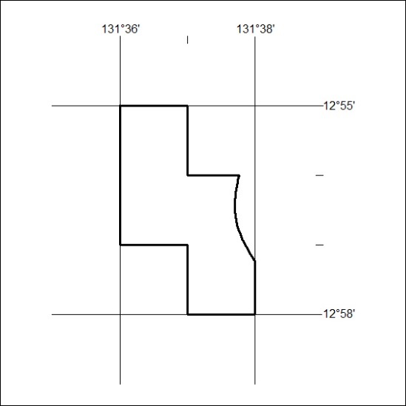
398/20

Mineral Titles Act 2010
NOTICE OF LAND CEASING TO BE A MINERAL TITLE AREA
Title Type and Number: | Extractive Mineral Exploration Licence 31923
Area Ceased on: | 04 December 2020
Area: | 4 Blocks, 13.39 km²
Locality: | MARY RIVER
Name of Applicant(s)/Holder(s): | 100% MT ROMANCE (NT) PTY LTD [ACN. 623 930 594]
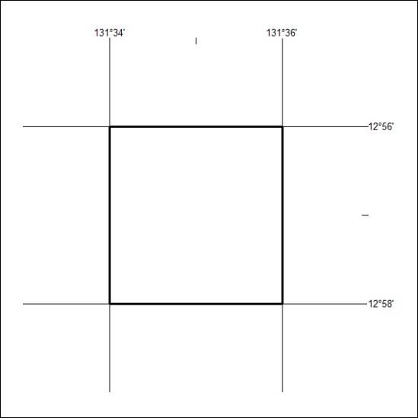
399/20

