Mineral Titles Act 2010
NOTICE OF LAND CEASING TO BE A MINERAL TITLE AREA
Title Type and Number: | Extractive Mineral Permit 31559
Area ceased on: | 19 November 2020
Area: | 63.00 Hectare
Locality: | NOONAMAH
Name of Applicants(s)Holder(s): | 100% ALISANTE HOLDINGS PTY LTD [ACN. 067 361 559]
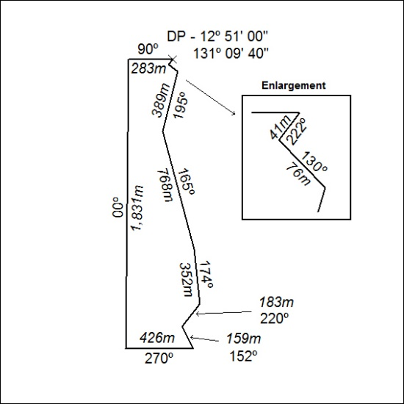

377/20

Mineral Titles Act 2010
NOTICE OF LAND CEASING TO BE A MINERAL TITLE AREA
Title Type and Number: | Extractive Mineral Permit 31560
Area ceased on: | 19 November 2020
Area: | 92.00 Hectare
Locality: | NOONAMAH
Name of Applicants(s)Holder(s): | 100% ALISANTE HOLDINGS PTY LTD [ACN. 067 361 559]
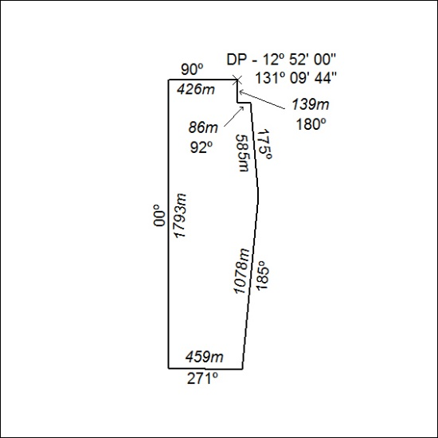

378/20

Mineral Titles Act 2010
NOTICE OF LAND CEASING TO BE A MINERAL TITLE AREA
Title Type and Number: | Extractive Mineral Permit 31561
Area ceased on: | 19 November 2020
Area: | 76.00 Hectare
Locality: | NOONAMAH
Name of Applicants(s)Holder(s): | 100% ALISANTE HOLDINGS PTY LTD [ACN. 067 361 559]
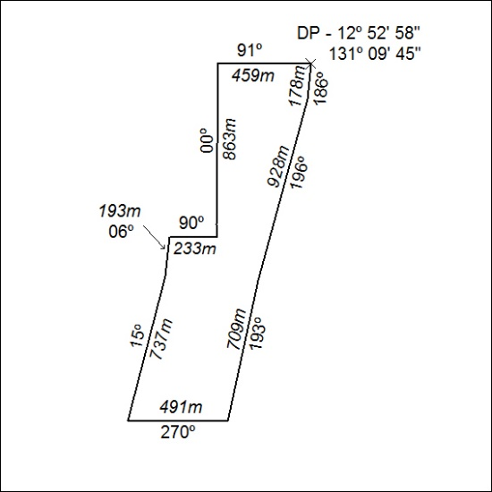

379/20

Mineral Titles Act 2010
NOTICE OF LAND CEASING TO BE A MINERAL TITLE AREA
Title Type and Number: | Extractive Mineral Permit 31577
Area ceased on: | 19 November 2020
Area: | 78.00 Hectare
Locality: | NOONAMAH
Name of Applicants(s)Holder(s): | 100% ALISANTE HOLDINGS PTY LTD [ACN. 067 361 559]
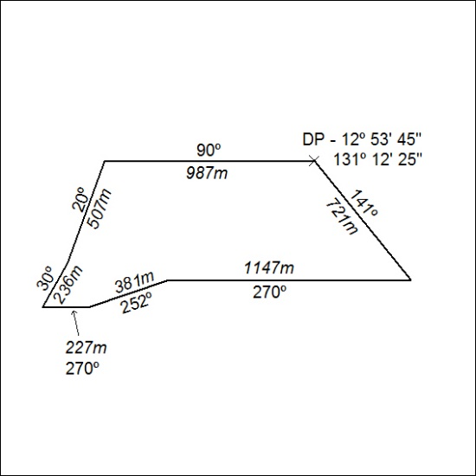

380/20

Mineral Titles Act 2010
NOTICE OF LAND CEASING TO BE A MINERAL TITLE AREA
Title Type and Number: | Extractive Mineral Permit 31578
Area ceased on: | 19 November 2020
Area: | 97.00 Hectare
Locality: | NOONAMAH
Name of Applicants(s)Holder(s): | 100% ALISANTE HOLDINGS PTY LTD [ACN. 067 361 559]
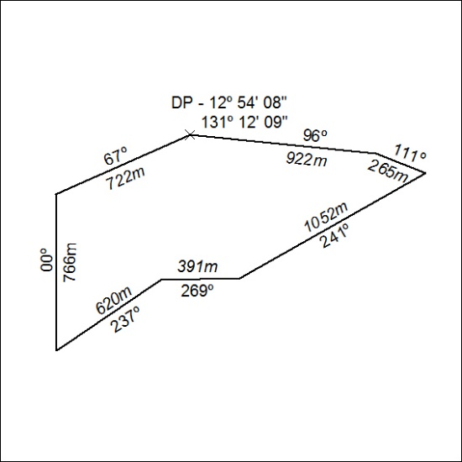

381/20

