Mineral Titles Act 2010
NOTICE OF LAND CEASING TO BE A MINERAL TITLE APPLICATION AREA
Title Type and Number: | Extractive Mineral Permit 31230
Area ceased on: | 16 October 2020
Area: | 8.00 Hectare
Locality: | REYNOLDS RIVER
Name of Applicants(s)Holder(s): | 100% KERR Daryn Troy
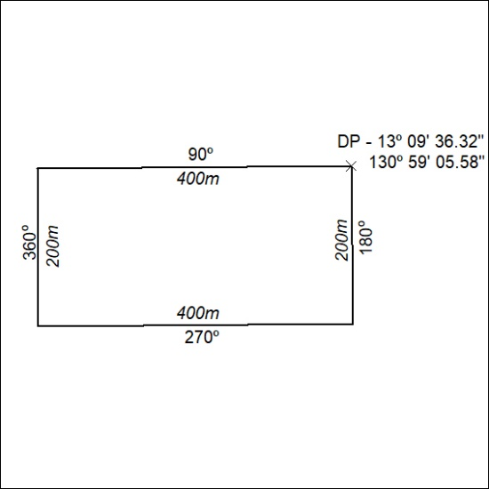

339/20

