Mineral Titles Act 2010
NOTICE OF LAND CEASING TO BE A MINERAL TITLE AREA
Title Type and Number: | Exploration Licence 31045
Area Ceased on: | 02 October 2020
Area: | 140 Blocks, 443.40 km²
Locality: | MANTUNGULA
Name of Applicant(s)/Holder(s): | 100% ALTA ZINC LIMITED* [ACN. 078 510 988]
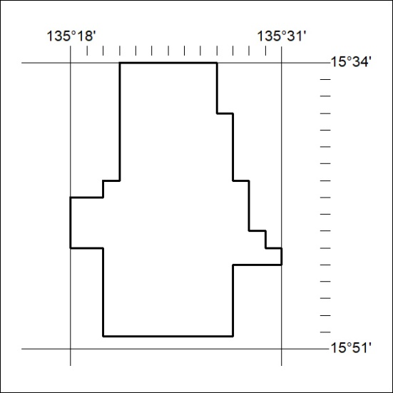
330/20

