Mineral Titles Act 2010
NOTICE OF LAND CEASING TO BE A MINERAL TITLE AREA
Title Type and Number: | Exploration Licence 31782
Area Ceased on: | 16 September 2020
Area: | 72 Blocks, 227.29 km²
Locality: | GLEN HELEN
Name of Applicant(s)/Holder(s): | 100% SCRIVEN EXPLORATION PTY LTD [ACN. 006 264 615]
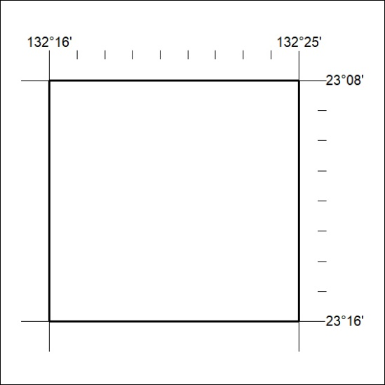

316/20

Mineral Titles Act 2010
NOTICE OF LAND CEASING TO BE A MINERAL TITLE AREA
Title Type and Number: | Exploration Licence 31783
Area Ceased on: | 16 September 2020
Area: | 24 Blocks, 75.76 km²
Locality: | NARWIETOOMA
Name of Applicant(s)/Holder(s): | 100% SCRIVEN EXPLORATION PTY LTD [ACN. 006 264 615]
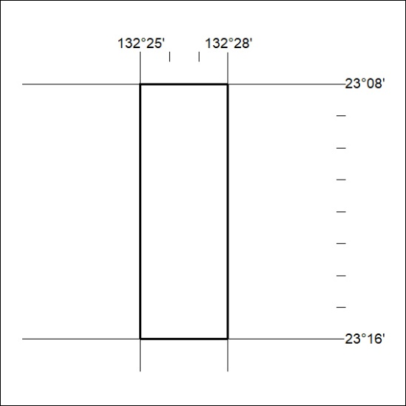

317/20

