Mineral Titles Act 2010
NOTICE OF LAND CEASING TO BE A MINERAL TITLE AREA
Title Type and Number: | Exploration Licence 31539
Area Ceased on: | 24 April 2020
Area: | 233 Blocks, 765.13 km²
Locality: | MONTEJINNI
Name of Applicant(s)/Holder(s): | 100% MONTEJINNI RESOURCES PTY LTD [ACN. 616 894 216]
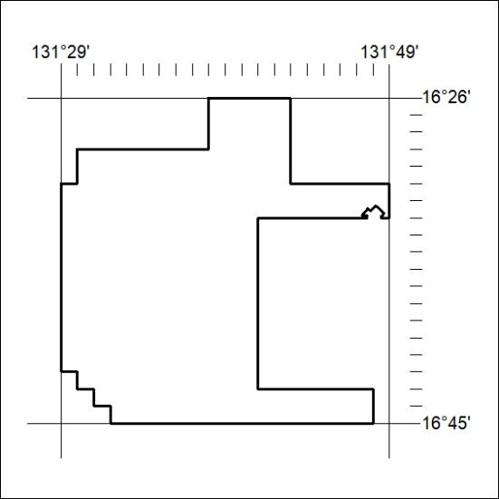
171/20

