Mineral Titles Act 2010
NOTICE OF LAND CEASING TO BE A MINERAL TITLE APPLICATION AREA
Title Type and Number: | Exploration Licence 32112
Area Ceased on: | 07 April 2020
Area: | 217 Blocks, 690.15 km²
Locality: | OORADIDGEE
Name of Applicant(s)/Holder(s): | 100% RESOURCE HOLDINGS (WA) PTY LTD [ACN. 079 106 684]
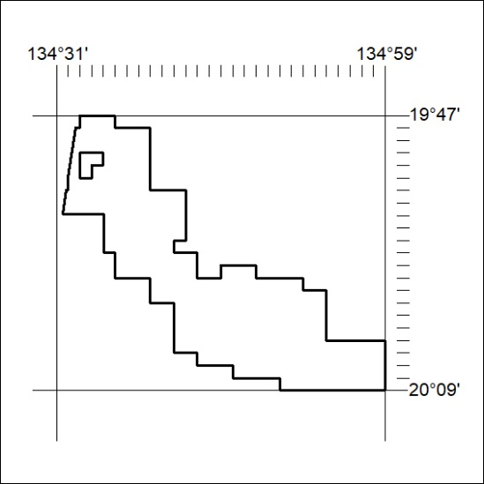

161/20

Mineral Titles Act 2010
NOTICE OF LAND CEASING TO BE A MINERAL TITLE AREA
Title Type and Number: | Extractive Mineral Permit 28716
Area ceased on: | 09 April 2020
Area: | 101.00 Hectares
Locality: | NOONAMAH
Name of Applicants(s)Holder(s): | 100% HI-SPEC CIVIL EQUIPMENT PTY LTD (IN LIQUIDATION) [ACN. 115 428 050]
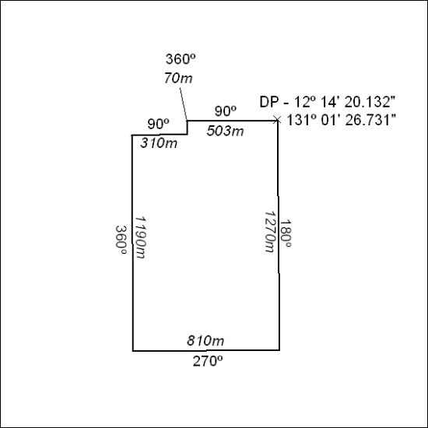

162/20

Mineral Titles Act 2010
NOTICE OF LAND CEASING TO BE A MINERAL TITLE AREA
Title Type and Number: | Extractive Mineral Permit 28719
Area ceased on: | 09 April 2020
Area: | 100.00 Hectare
Locality: | NOONAMAH
Name of Applicants(s)Holder(s): | 100% HI-SPEC CIVIL EQUIPMENT PTY LTD (IN LIQUIDATION) [ACN. 115 428 050]
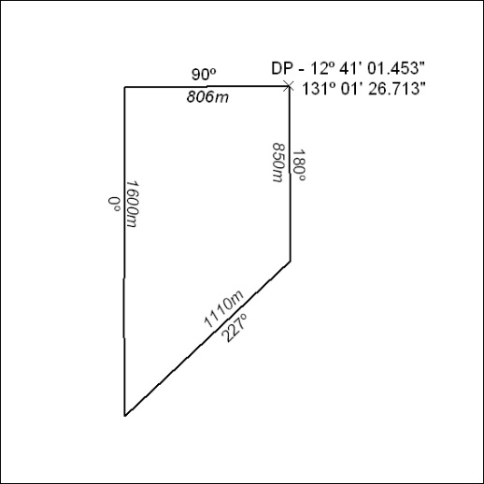

163/20

