Mineral Titles Act 2010
NOTICE OF LAND CEASING TO BE A MINERAL TITLE AREA
Title Type and Number: | Exploration Licence 31137
Area Ceased on: | 23 March 2020
Area: | 63 Blocks, 200.35 km²
Locality: | WOODGREEN
Name of Applicant(s)/Holder(s): | 100% LITHIUM PLUS PTY LTD [ACN. 626 593 799]
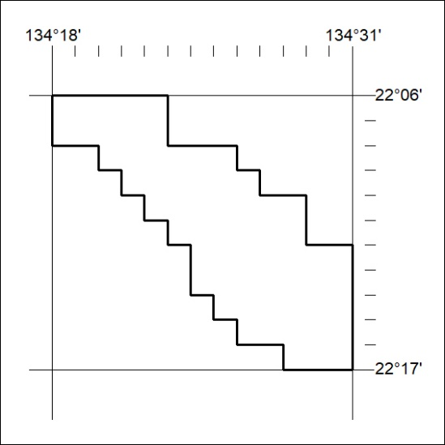
145/20

Mineral Titles Act 2010
NOTICE OF LAND CEASING TO BE A MINERAL TITLE AREA
Title Type and Number: | Exploration Licence 31209
Area Ceased on: | 23 March 2020
Area: | 90 Blocks, 280.40 km²
Locality: | WINGATE MOUNTAINS
Name of Applicant(s)/Holder(s): | 100% TODD RIVER METALS PTY LTD [ACN. 600 314 038]
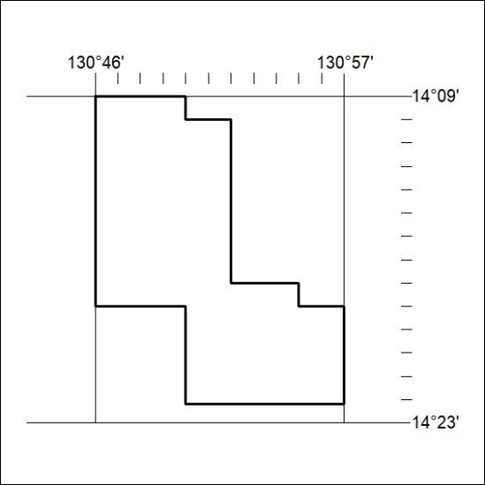
146/20

Mineral Titles Act 2010
NOTICE OF LAND CEASING TO BE A MINERAL TITLE AREA
Title Type and Number: | Exploration Licence 31213
Area Ceased on: | 23 March 2020
Area: | 95 Blocks, 286.63 km²
Locality: | WOODGREEN
Name of Applicant(s)/Holder(s): | 100% LITHIUM PLUS PTY LTD [ACN. 626 593 799]
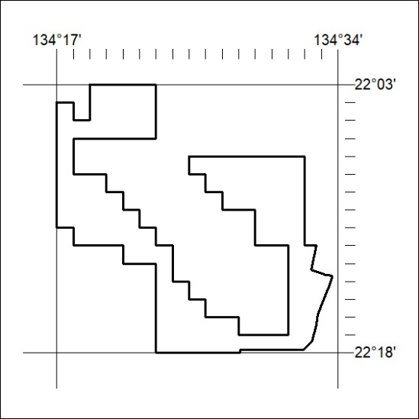
147/20

Mineral Titles Act 2010
NOTICE OF LAND CEASING TO BE A MINERAL TITLE AREA
Title Type and Number: | Exploration Licence 31265
Area Ceased on: | 23 March 2020
Area: | 51 Blocks, 164.52 km²
Locality: | HELEN
Name of Applicant(s)/Holder(s): | 100% TODD RIVER METALS PTY LTD [ACN. 600 314 038]
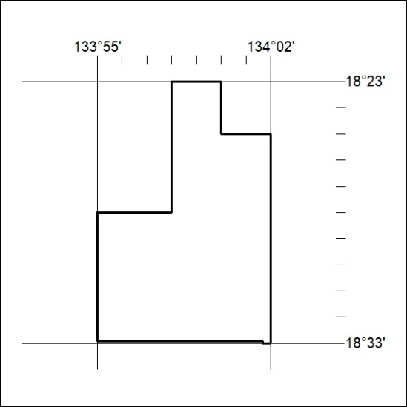
148/20

Mineral Titles Act 2010
NOTICE OF LAND CEASING TO BE A MINERAL TITLE AREA
Title Type and Number: | Exploration Licence 31953
Area Ceased on: | 23 March 2020
Area: | 42 Blocks, 137.53 km²
Locality: | INVERWAY
Name of Applicant(s)/Holder(s): | 100% TERRITORY PROSPECTING PTY LTD [ACN. 627 334 034]
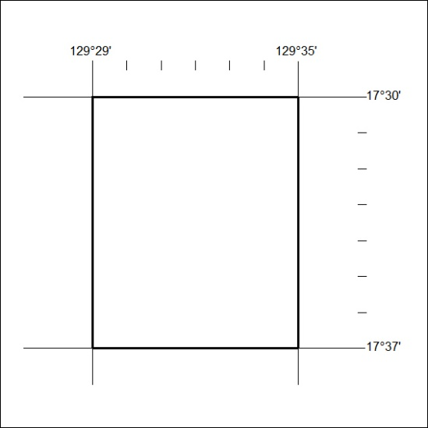
149/20

Mineral Titles Act 2010
NOTICE OF LAND CEASING TO BE A MINERAL TITLE AREA
Title Type and Number: | Exploration Licence 31955
Area Ceased on: | 23 March 2020
Area: | 25 Blocks, 81.83 km²
Locality: | NAPIER
Name of Applicant(s)/Holder(s): | 100% TERRITORY PROSPECTING PTY LTD [ACN. 627 334 034]
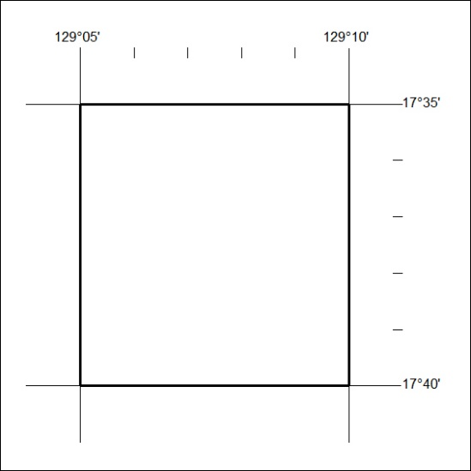
150/20

Mineral Titles Act 2010
NOTICE OF LAND CEASING TO BE A MINERAL TITLE AREA
Title Type and Number: | Exploration Licence 31958
Area Ceased on: | 23 March 2020
Area: | 24 Blocks, 76.16 km²
Locality: | FLORA
Name of Applicant(s)/Holder(s): | 100% TERRITORY PROSPECTING PTY LTD [ACN. 627 334 034]
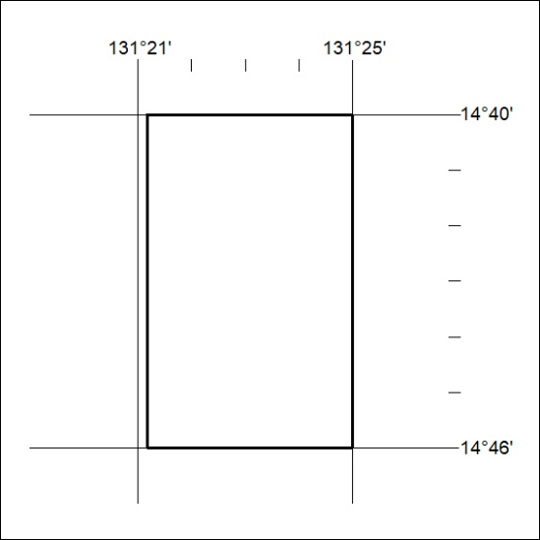
151/20

Mineral Titles Act 2010
NOTICE OF LAND CEASING TO BE A MINERAL TITLE AREA
Title Type and Number: | Exploration Licence 31962
Area Ceased on: | 23 March 2020
Area: | 50 Blocks, 160.17 km²
Locality: | FLORA
Name of Applicant(s)/Holder(s): | 100% TERRITORY PROSPECTING PTY LTD [ACN. 627 334 034]
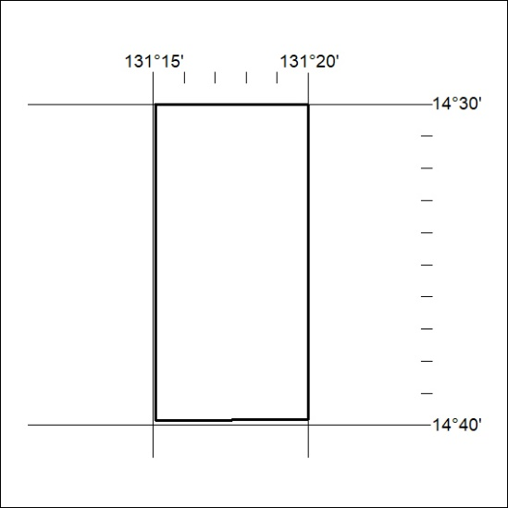
152/20

Mineral Titles Act
NOTICE OF GRANT OF A MINERAL TITLE
Title Type and Number: | Exploration Licence 32244
Granted: | 23 March 2020, for a period of 6 Years
Area: | 204 Blocks, 639.68 km²
Locality: | TODD
Name of Holder/s: | 100% GEMPART (NT) PTY LTD* [ACN. 081 859 896]
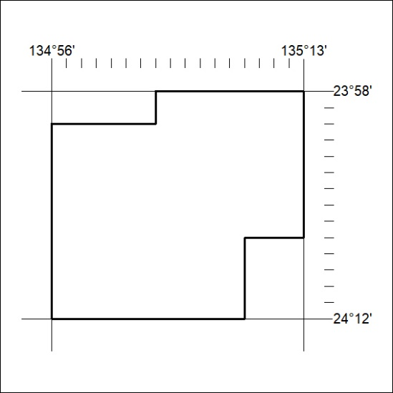
Area granted is indicated above. The titleholder is not permitted to exercise occupational rights on any land that is subject to a development title, or an application for a development title. Any land the subject of a Reserved Land gazettal under the Mineral Titles Act and all land vested in the Commonwealth of Australia is also excluded by description but not excised from the grant area.
153/20

