Mineral Titles Act 2010
NOTICE OF LAND CEASING TO BE A MINERAL TITLE AREA
Title Type and Number: | Mineral Lease 31397
Area ceased on: | 09 December 2019
Area: | 112.00 Hectares
Locality: | QUARTZ
Name of Applicants(s)Holder(s): | 100% BARFUSS CORPORATION PTY. LTD. [ACN. 006 917 666]
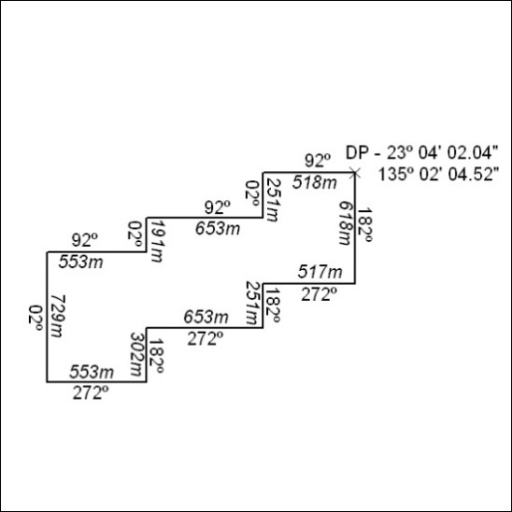

521/19

Mineral Titles Act 2010
NOTICE OF LAND CEASING TO BE A MINERAL TITLE AREA
Title Type and Number: | Mineral Lease 31401
Area ceased on: | 09 December 2019
Area: | 57.00 Hectare
Locality: | QUARTZ
Name of Applicants(s)Holder(s): | 100% BARFUSS CORPORATION PTY. LTD. [ACN. 006 917 666]
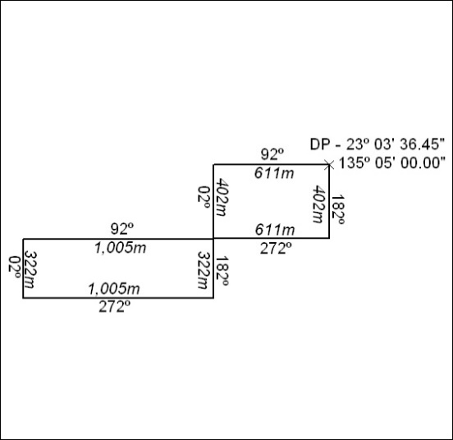

522/19
Mineral Titles Act 2010
NOTICE OF LAND CEASING TO BE A MINERAL TITLE AREA
Title Type and Number: | Exploration Licence 24196
Area Ceased on: | 09 December 2019
Area: | 12 Blocks, 39.16 km²
Locality: | CORELLA CREEK
Name of Applicant(s)/Holder(s): | 100% MARENGO MINING (AUSTRALIA) PTY LTD* [ACN. 099 496 474]
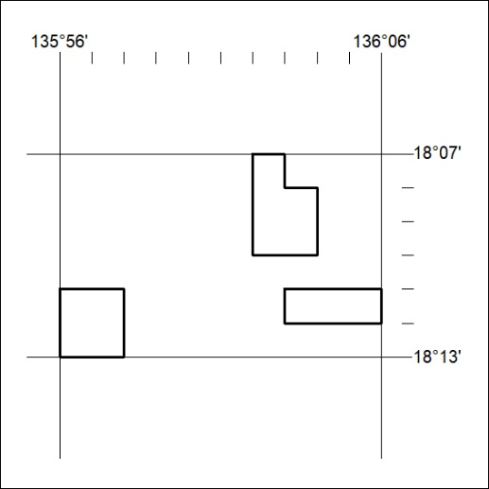

523/19

Mineral Titles Act 2010
NOTICE OF LAND CEASING TO BE A MINERAL TITLE APPLICATION AREA
Title Type and Number: | Exploration Licence 25045
Area Ceased on: | 09 December 2019
Area: | 475 Blocks, 1490.85 km²
Locality: | GILL
Name of Applicant(s)/Holder(s): | 100% NOVA ENERGY PTY LTD* [ACN. 111 599 154]
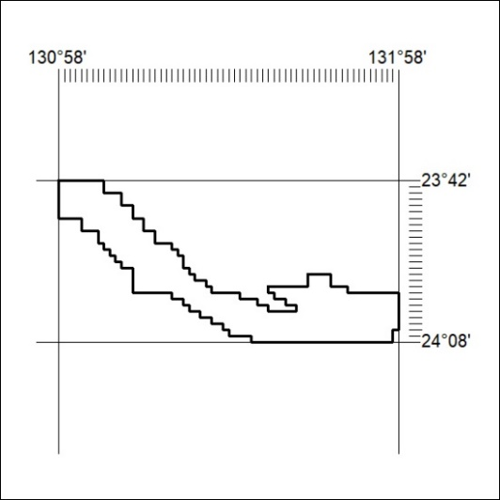

524/19
Mineral Titles Act 2010
NOTICE OF LAND CEASING TO BE A MINERAL TITLE APPLICATION AREA
Title Type and Number: | Exploration Licence 25046
Area Ceased on: | 09 December 2019
Area: | 246 Blocks, 772.86 km²
Locality: | TARAWERA
Name of Applicant(s)/Holder(s): | 100% NOVA ENERGY PTY LTD* [ACN. 111 599 154]
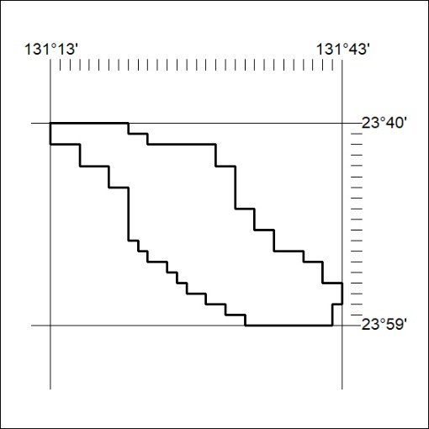

525/19

Mineral Titles Act 2010
NOTICE OF LAND CEASING TO BE A MINERAL TITLE AREA
Title Type and Number: | Exploration Licence 28155
Area Ceased on: | 09 December 2019
Area: | 11 Blocks, 31.38 km²
Locality: | MACDONNELL RANGES
Name of Applicant(s)/Holder(s): | 100% CROSSLAND NICKEL PTY LTD* [ACN. 099 477 915]
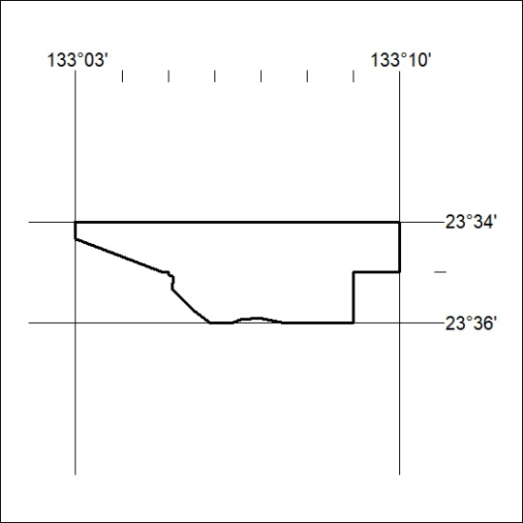

526/19
Mineral Titles Act 2010
NOTICE OF LAND CEASING TO BE A MINERAL TITLE AREA
Title Type and Number: | Exploration Licence 28866
Area Ceased on: | 09 December 2019
Area: | 5 Blocks, 15.75 km²
Locality: | ANBURLA
Name of Applicant(s)/Holder(s): | 56.28% CROSSLAND NICKEL PTY LTD* [ACN. 099 477 915], 43.72% ESSENTIAL MINING RESOURCES PTY LTD [ACN. 601 655 725]
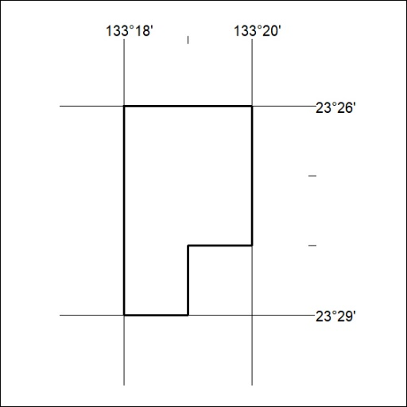

527/19

Mineral Titles Act 2010
NOTICE OF LAND CEASING TO BE A MINERAL TITLE AREA
Title Type and Number: | Exploration Licence 30294
Area Ceased on: | 09 December 2019
Area: | 44 Blocks, 139.39 km²
Locality: | JERVOIS RANGE
Name of Applicant(s)/Holder(s): | 100% BOWGAN MINERALS LTD [ACN. 137 527 336]
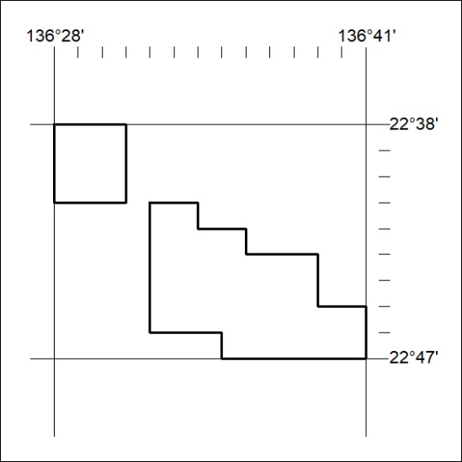

528/19

Mineral Titles Act
NOTICE OF GRANT OF A MINERAL TITLE
Title Type and Number: | Exploration Licence 32064
Granted: | 05 December 2019, for a period of 6 Years
Area: | 127 Blocks, 414.18 km²
Locality: | KILLARNEY
Name of Holder/s: | 100% WRIGHT Anthony
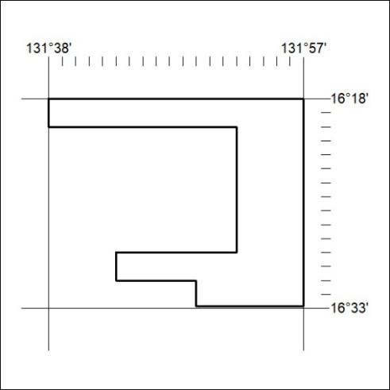
Area granted is indicated above. The titleholder is not permitted to exercise occupational rights on any land that is subject to a development title, or an application for a development title. Any land the subject of a Reserved Land gazettal under the Mineral Titles Act and all land vested in the Commonwealth of Australia is also excluded by description but not excised from the grant area.

529/19

Mineral Titles Act
NOTICE OF GRANT OF A MINERAL TITLE
Title Type and Number: | Exploration Licence 32123
Granted: | 05 December 2019, for a period of 6 Years
Area: | 38 Blocks, 119.80 km²
Locality: | QUARTZ
Name of Holder/s: | 100% TYPHON MINERALS PTY LTD [ACN. 614 887 464]
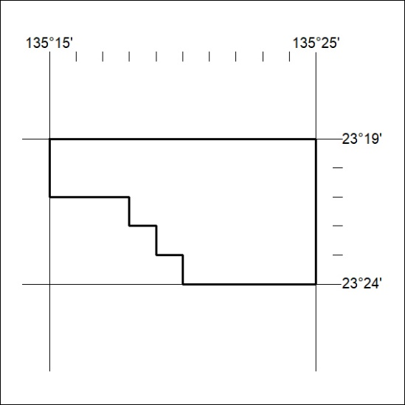
Area granted is indicated above. The titleholder is not permitted to exercise occupational rights on any land that is subject to a development title, or an application for a development title. Any land the subject of a Reserved Land gazettal under the Mineral Titles Act and all land vested in the Commonwealth of Australia is also excluded by description but not excised from the grant area.

530/19

