Mineral Titles Act 2010
NOTICE OF LAND CEASING TO BE A MINERAL TITLE AREA
Title Type and Number: | Exploration Licence 30846
Area Ceased on: | 22 November 2019
Area: | 111 Blocks, 355.02 km²
Locality: | KILGOUR
Name of Applicant(s)/Holder(s): | 100% MMG EXPLORATION PTY LTD* [ACN. 119 136 659]
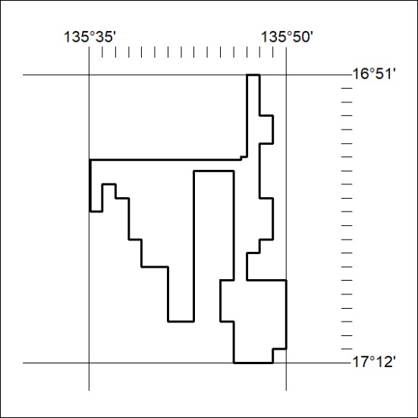

497/19

Mineral Titles Act 2010
NOTICE OF LAND CEASING TO BE A MINERAL TITLE AREA
Title Type and Number: | Exploration Licence 31014
Area Ceased on: | 22 November 2019
Area: | 30 Blocks, 98.51 km²
Locality: | KILGOUR
Name of Applicant(s)/Holder(s): | 100% MMG EXPLORATION PTY LTD* [ACN. 119 136 659]
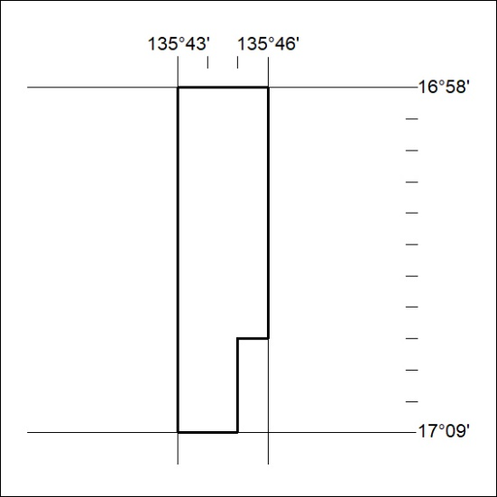

498/19
Mineral Titles Act 2010
NOTICE OF LAND CEASING TO BE A MINERAL TITLE AREA
Title Type and Number: | Exploration Licence 31100
Area Ceased on: | 22 November 2019
Area: | 21 Blocks, 68.95 km²
Locality: | KILGOUR
Name of Applicant(s)/Holder(s): | 100% MMG EXPLORATION PTY LTD* [ACN. 119 136 659]
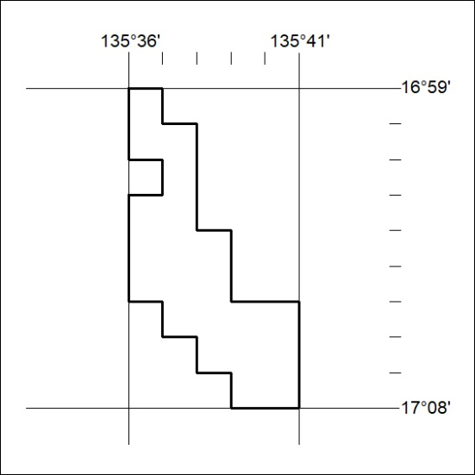

499/19

