Mineral Titles Act 2010
NOTICE OF LAND CEASING TO BE A MINERAL TITLE AREA
Title Type and Number: | Exploration Licence 28045
Area Ceased on: | 24 October 2019
Area: | 23 Blocks, 72.63 km²
Locality: | LAUGHLEN
Name of Applicant(s)/Holder(s): | 100% DAVENPORT RESOURCES LIMITED* [ACN. 153 414 852]
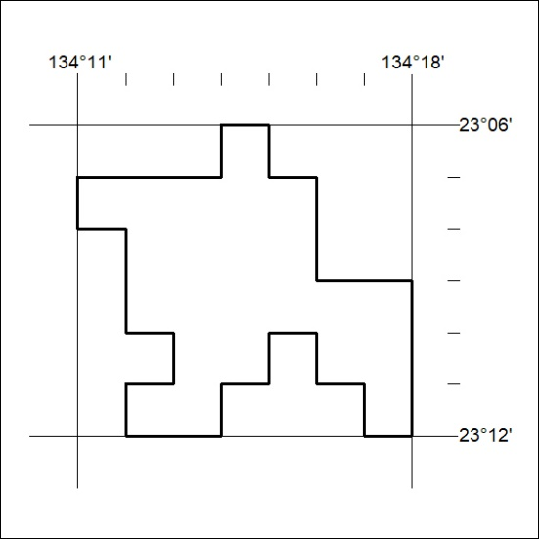

457/19

Mineral Titles Act 2010
NOTICE OF LAND CEASING TO BE A MINERAL TITLE AREA
Title Type and Number: | Exploration Licence 30090
Area Ceased on: | 24 October 2019
Area: | 54 Blocks, 136.89 km²
Locality: | LAUGHLEN
Name of Applicant(s)/Holder(s): | 100% DAVENPORT RESOURCES LIMITED* [ACN. 153 414 852]
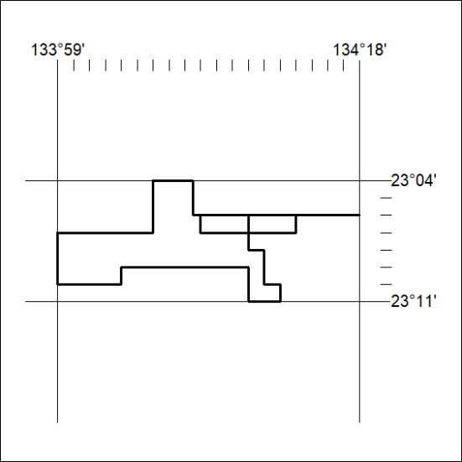

458/19
Mineral Titles Act 2010
NOTICE OF LAND CEASING TO BE A MINERAL TITLE AREA
Title Type and Number: | Exploration Licence 30665
Area Ceased on: | 24 October 2019
Area: | 34 Blocks, 110.54 km²
Locality: | MITCHIEBO
Name of Applicant(s)/Holder(s): | 100% TECK AUSTRALIA PTY LTD [ACN. 091 271 911]
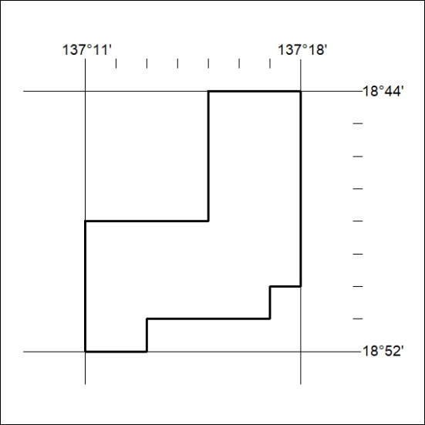

459/19

