Mineral Titles Act 2010
NOTICE OF LAND CEASING TO BE A MINERAL TITLE AREA
Title Type and Number: | Extractive Mineral Exploration Licence 31112
Area Ceased on: | 18 October 2019
Area: | 4 Blocks, 13.01 km²
Locality: | BRUNCHILLY
Name of Applicant(s)/Holder(s): | 100% EARTHWORKS NT PTY LTD [ACN. 145 461 169]
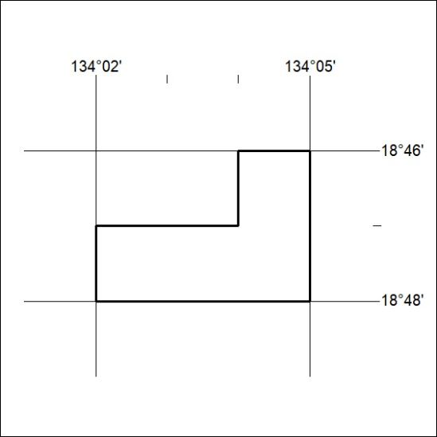

449/19

Mineral Titles Act 2010
NOTICE OF LAND CEASING TO BE A MINERAL TITLE AREA
Title Type and Number: | Exploration Licence 29557
Area Ceased on: | 22 October 2019
Area: | 37 Blocks, 120.25 km²
Locality: | MITCHIEBO
Name of Applicant(s)/Holder(s): | 100% TECK AUSTRALIA PTY LTD [ACN. 091 271 911]
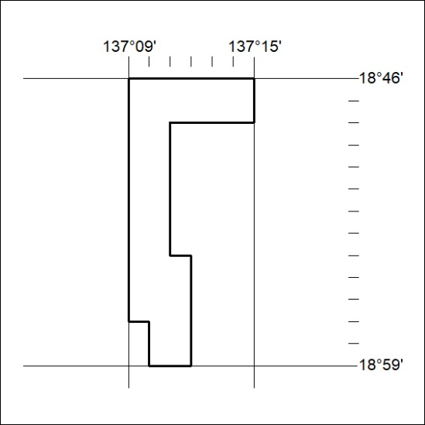

450/19
Mineral Titles Act 2010
NOTICE OF LAND CEASING TO BE A MINERAL TITLE AREA
Title Type and Number: | Exploration Licence 29560
Area Ceased on: | 22 October 2019
Area: | 17 Blocks, 55.32 km²
Locality: | CARRARA
Name of Applicant(s)/Holder(s): | 100% TECK AUSTRALIA PTY LTD [ACN. 091 271 911]
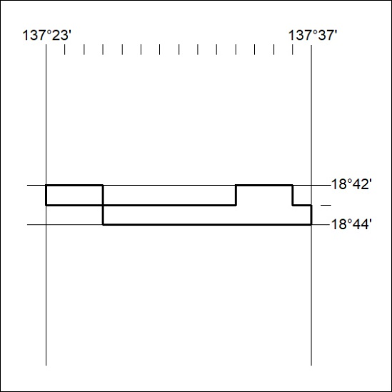

451/19

Mineral Titles Act 2010
NOTICE OF LAND CEASING TO BE A MINERAL TITLE AREA
Title Type and Number: | Exploration Licence 30816
Area Ceased on: | 22 October 2019
Area: | 28 Blocks, 90.98 km²
Locality: | MITCHIEBO
Name of Applicant(s)/Holder(s): | 100% TECK AUSTRALIA PTY LTD [ACN. 091 271 911]
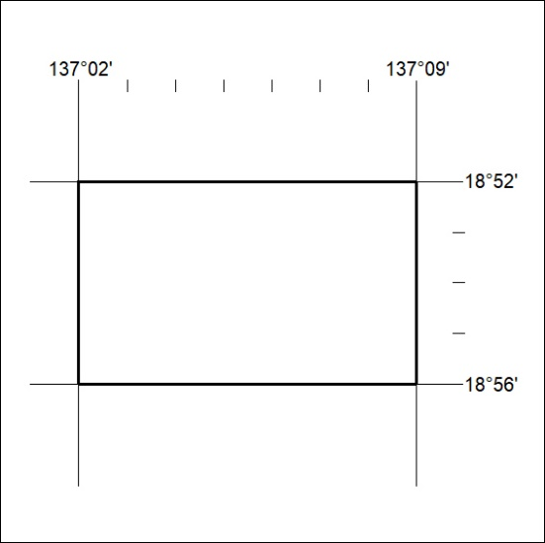

452/19
Mineral Titles Act 2010
NOTICE OF LAND CEASING TO BE A MINERAL TITLE AREA
Title Type and Number: | Exploration Licence 31538
Area Ceased on: | 22 October 2019
Area: | 56 Blocks, 181.96 km²
Locality: | MITCHIEBO
Name of Applicant(s)/Holder(s): | 100% TECK AUSTRALIA PTY LTD [ACN. 091 271 911]
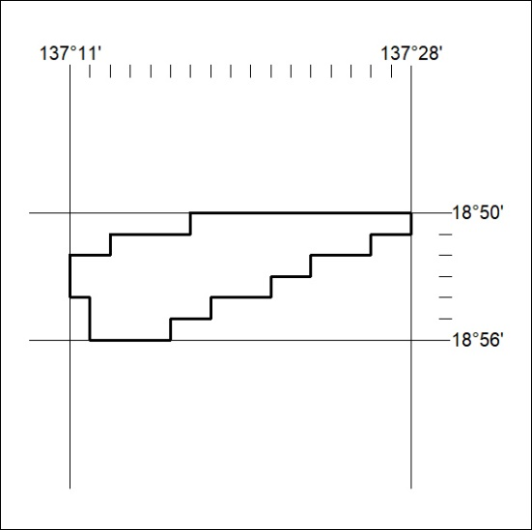

453/19

