Mineral Titles Act 2010
NOTICE OF LAND CEASING TO BE A MINERAL TITLE AREA
Title Type and Number: | Exploration Licence 27359
Area Ceased on: | 16 October 2019
Area: | 31 Blocks, 97.76 km²
Locality: | ANBURLA
Name of Applicant(s)/Holder(s): | 100% CROSSLAND NICKEL PTY LTD* [ACN. 099 477 915]
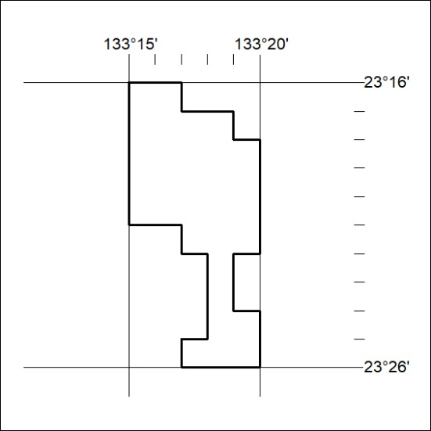
428/19

Mineral Titles Act 2010
NOTICE OF LAND CEASING TO BE A MINERAL TITLE AREA
Title Type and Number: | Exploration Licence 28795
Area Ceased on: | 16 October 2019
Area: | 3 Blocks, 9.46 km²
Locality: | ANBURLA
Name of Applicant(s)/Holder(s): | 56.28% CROSSLAND NICKEL PTY LTD* [ACN. 099 477 915], 43.72% ESSENTIAL MINING RESOURCES PTY LTD [ACN. 601 655 725]
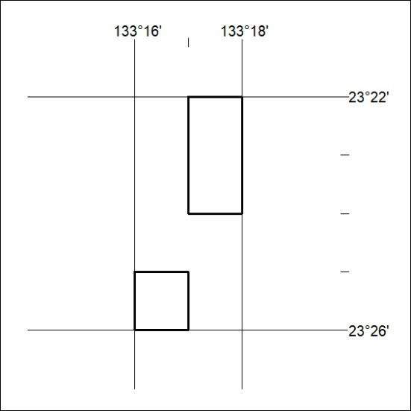
429/19

Mineral Titles Act 2010
NOTICE OF LAND CEASING TO BE A MINERAL TITLE AREA
Title Type and Number: | Exploration Licence 30801
Area Ceased on: | 13 October 2019
Area: | 82 Blocks, 258.13 km²
Locality: | LURAPULLA
Name of Applicant(s)/Holder(s): | 100% OATES Tom Michael
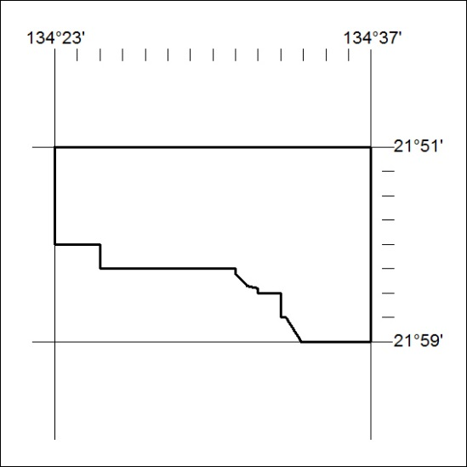
430/19

Mineral Titles Act 2010
NOTICE OF LAND CEASING TO BE A MINERAL TITLE AREA
Title Type and Number: | Exploration Licence 31251
Area Ceased on: | 16 October 2019
Area: | 116 Blocks, 352.78 km²
Locality: | ILLOGWA
Name of Applicant(s)/Holder(s): | 100% GEMPART (NT) PTY LTD* [ACN. 081 859 896]
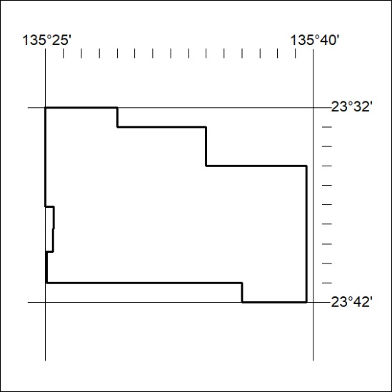
431/19

