Mineral Titles Act
NOTICE OF GRANT OF A MINERAL TITLE
Title Type and Number: | Extractive Mineral Permit 32119
Granted: | 01 October 2019, for a period of 5 Years
Area: | 16.94 Hectares
Locality: | MANBULLOO
Name of Holder/s: | 100% HY-TEC INDUSTRIES (NORTHERN TERRITORY) PTY LTD [ACN. 096 310 824]
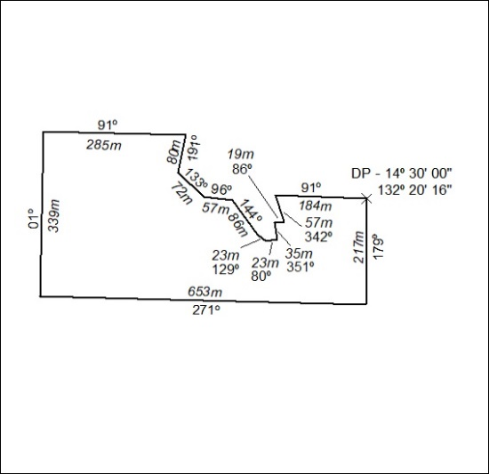

415/19

