Mineral Titles Act 2010
NOTICE OF LAND CEASING TO BE A MINERAL TITLE AREA
Title Type and Number: | Exploration Licence 27995
Area Ceased on: | 17 September 2019
Area: | 25 Blocks, 80.25 km²
Locality: | INNINGARRA
Name of Applicant(s)/Holder(s): | 85% RAMELIUS RESOURCES LIMITED [ACN. 001 717 540], 15% TYCHEAN TANAMI PTY LTD* [ACN. 137 135 847]
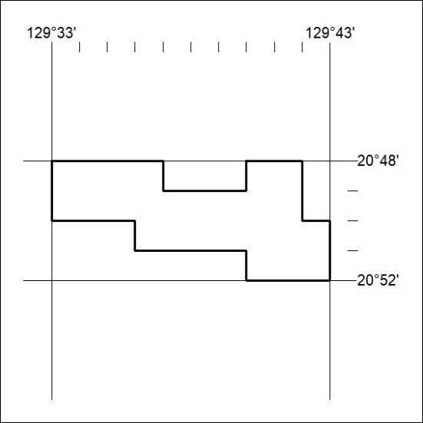

395/19

Mineral Titles Act
NOTICE OF GRANT OF A MINERAL TITLE
Title Type and Number: | Exploration Licence 32087
Granted: | 18 September 2019, for a period of 6 Years
Area: | 2 Blocks, 6.68 km²
Locality: | BATCHELOR
Name of Holder/s: | 100% TOTTEN Robert
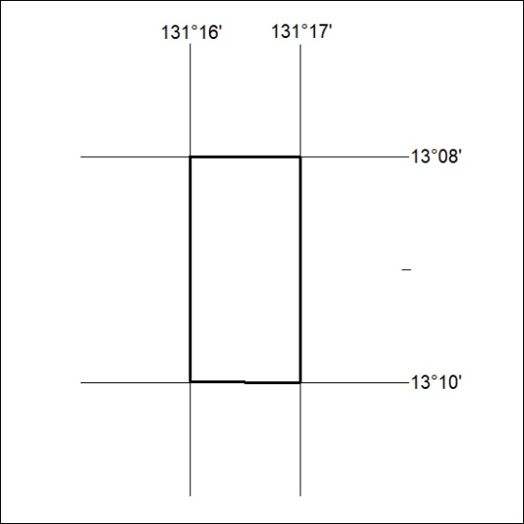
Area granted is indicated above. The titleholder is not permitted to exercise occupational rights on any land that is subject to a development title, or an application for a development title. Any land the subject of a Reserved Land gazettal under the Mineral Titles Act and all land vested in the Commonwealth of Australia is also excluded by description but not excised from the grant area.

396/19

