Mineral Titles Act
NOTICE OF GRANT OF A MINERAL TITLE
Title Type and Number: | Exploration Licence 32016
Granted: | 28 June 2019, for a period of 6 Years
Area: | 36 Blocks, 110.44 km²
Locality: | DALY RIVER
Name of Holder/s: | 100% HAMERSLEY METALS PTY LTD [ACN. 622 868 213]
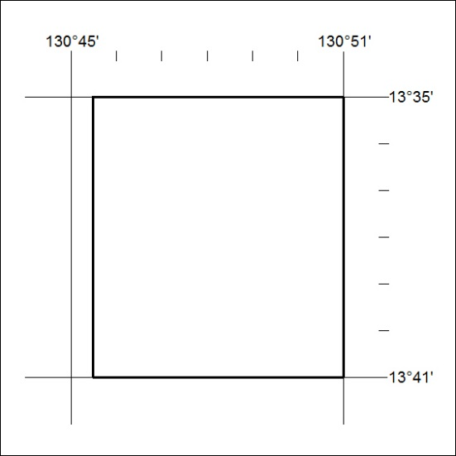
Area granted is indicated above. The titleholder is not permitted to exercise occupational rights on any land that is subject to a development title, or an application for a development title. Any land the subject of a Reserved Land gazettal under the Mineral Titles Act and all land vested in the Commonwealth of Australia is also excluded by description but not excised from the grant area.
271/19

Mineral Titles Act
NOTICE OF GRANT OF A MINERAL TITLE
Title Type and Number: | Extractive Mineral Exploration Licence 32023
Granted: | 01 July 2019, for a period of 2 Years
Area: | 4 Blocks, 10.57 km²
Locality: | BYNOE
Name of Holder/s: | 100% BEMINI PTY LTD [ACN. 608 851 430]
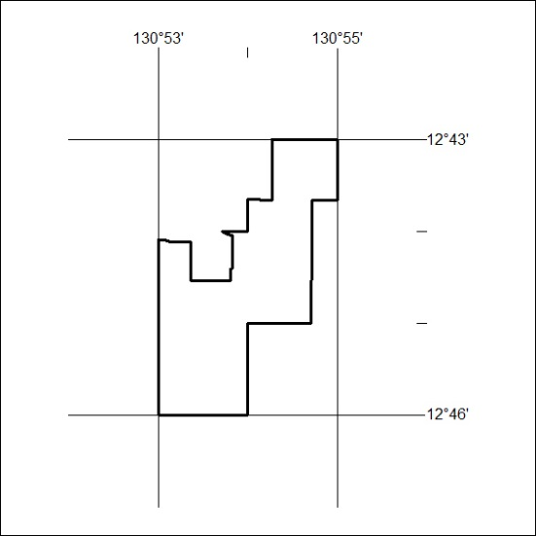
Area granted is indicated above. The titleholder is not permitted to exercise occupational rights on any land that is subject to a development title, or an application for a development title. Any land the subject of a Reserved Land gazettal under the Mineral Titles Act and all land vested in the Commonwealth of Australia is also excluded by description but not excised from the grant area.
272/19

Mineral Titles Act
NOTICE OF GRANT OF A MINERAL TITLE
Title Type and Number: | Extractive Mineral Exploration Licence 32024
Granted: | 01 July 2019, for a period of 2 Years
Area: | 3 Blocks, 6.44 km²
Locality: | NOONAMAH
Name of Holder/s: | 100% BEMINI PTY LTD [ACN. 608 851 430]
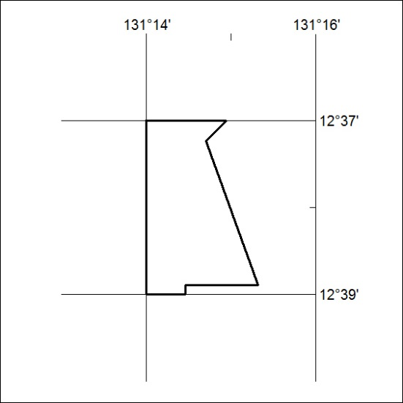
Area granted is indicated above. The titleholder is not permitted to exercise occupational rights on any land that is subject to a development title, or an application for a development title. Any land the subject of a Reserved Land gazettal under the Mineral Titles Act and all land vested in the Commonwealth of Australia is also excluded by description but not excised from the grant area.
273/19

