Mineral Titles Act 2010
NOTICE OF LAND CEASING TO BE A MINERAL TITLE APPLICATION AREA
Title Type and Number: | Exploration Licence 32118
Area Ceased on: | 15 May 2019
Area: | 17 Blocks, 56.79 km²
Locality: | McKINLAY RIVER
Name of Applicant(s)/Holder(s): | 100% WILD BULL RESOURCES LIMITED [ACN. 109 681 478]
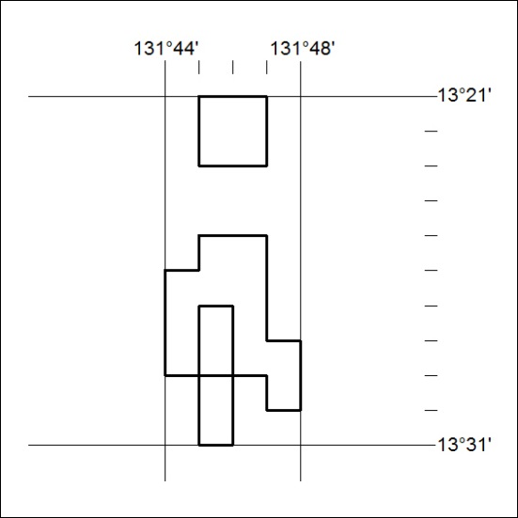

177/19

Mineral Titles Act
NOTICE OF GRANT OF A MINERAL TITLE
Title Type and Number: | Exploration Licence 32001
Granted: | 15 May 2019, for a period of 6 Years
Area: | 14 Blocks, 45.35 km²
Locality: | SHORT RANGE
Name of Holder/s: | 100% EVOLUTION TENNANT CREEK PTY LTD [ACN. 169 920 745]
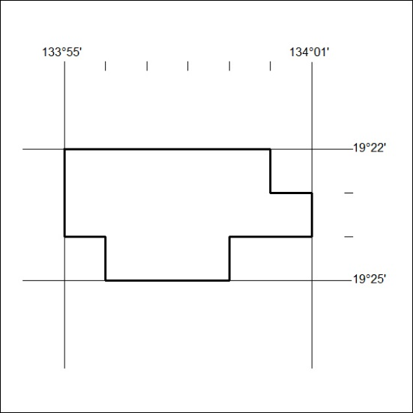
Area granted is indicated above. The titleholder is not permitted to exercise occupational rights on any land that is subject to a development title, or an application for a development title. Any land the subject of a Reserved Land gazettal under the Mineral Titles Act and all land vested in the Commonwealth of Australia is also excluded by description but not excised from the grant area.

178/19

