Mineral Titles Act
NOTICE OF LAND CEASING TO BE A MINERAL TITLE AREA
Title Type and Number: | Exploration Licence 22301
Area Ceased on: | 14 April 2019
Area: | 7 Blocks, 23.38 km²
Locality: | McKINLAY RIVER
Name of Applicant(s)/Holder(s): | 100% OUTBACK METALS PROPRIETARY LIMITED* [ACN. 126 797 573]
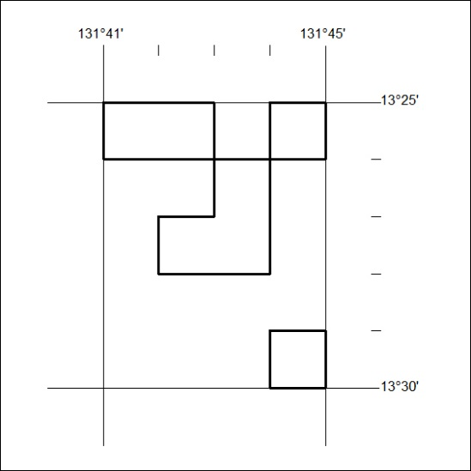

126/19

Mineral Titles Act 2010
NOTICE OF LAND CEASING TO BE A MINERAL TITLE AREA
Title Type and Number: | Exploration Licence 31821
Area Ceased on: | 15 April 2019
Area: | 59 Blocks, 170.18 km²
Locality: | DOREEN
Name of Applicant(s)/Holder(s): | 100% ENERGY METALS LTD [ACN. 111 306 533]
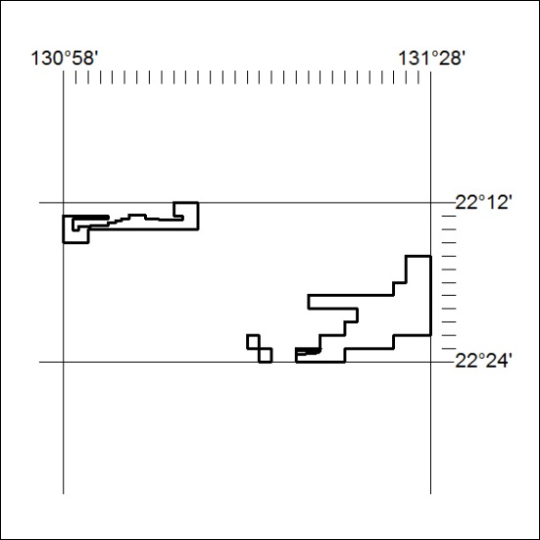
(Area now divided into Exploration Licence EL32108 under s101 – EL moratorium period does not apply)

127/19

