Mineral Titles Act
NOTICE OF LAND CEASING TO BE A MINERAL TITLE AREA
Title Type and Number: | Exploration Licence 31542
Area Ceased on: | 12 February 2019
Area: | 75 Blocks, 227.08 km²
Locality: | BRAHMA
Name of Applicant(s)/Holder(s): | 100% GBE EXPLORATION PTY LTD [ACN. 121 535 948]
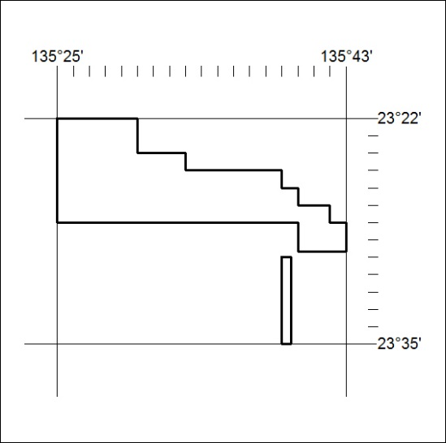

53/19

