Mineral Titles Act
NOTICE OF LAND CEASING TO BE A MINERAL TITLE AREA
Title Type and Number: | Exploration Licence 30040
Area Ceased on: | 25 October 2018
Area: | 4 Blocks, 12.59 km²
Locality: | DAVENPORT RANGE
Name of Applicant(s)/Holder(s): | 20% DUNNELL Kevin, 20% FALZON Angelo, 20% HALL Mary Anne, 20% HALL Thomas Raymond, 20% HOPPE Andrew Steven
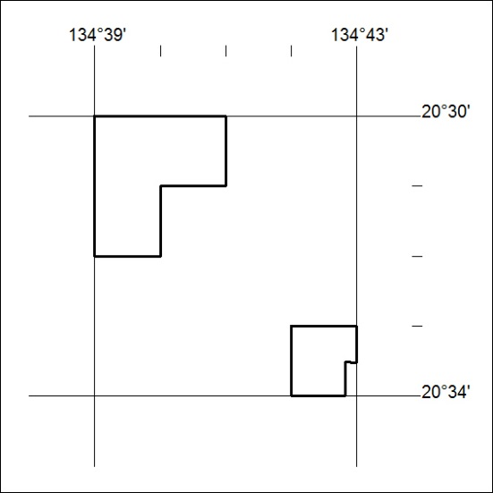

476/18

Mineral Titles Act
NOTICE OF LAND CEASING TO BE A MINERAL TITLE AREA
Title Type and Number: | Extractive Mineral Exploration Licence 31223
Area Ceased on: | 25 October 2018
Area: | 4 Blocks, 10.57 km²
Locality: | BYNOE
Name of Applicant(s)/Holder(s): | 100% RISK William Maxwell
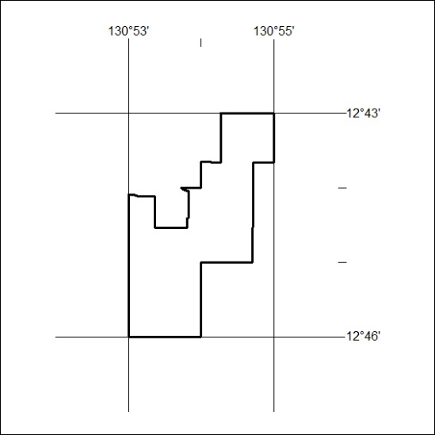

477/18

Mineral Titles Act
NOTICE OF LAND CEASING TO BE A MINERAL TITLE AREA
Title Type and Number: | Extractive Mineral Exploration Licence 31233
Area Ceased on: | 25 October 2018
Area: | 3 Blocks, 6.44 km²
Locality: | NOONAMAH
Name of Applicant(s)/Holder(s): | 100% RISK William Maxwell
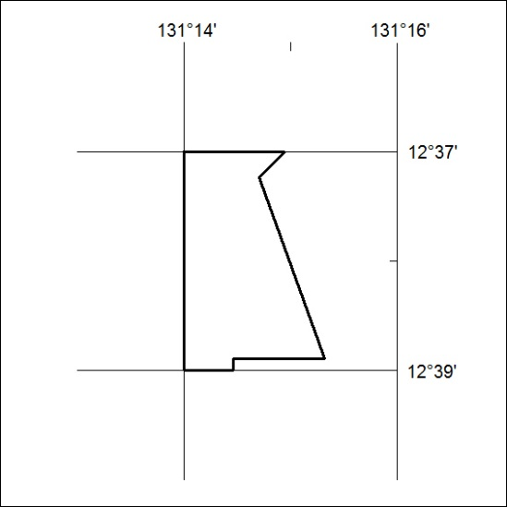

478/18

Mineral Titles Act
NOTICE OF LAND CEASING TO BE A MINERAL TITLE
Title Type and Number: | Mineral Authority 511
Area ceased on: | 24 October 2018
Area: | 28.00 Hectare
Locality: | BYNOE
Name of Applicants(s)Holder(s): | 100% A AND SF MADDALOZZO PTY. LIMITED [ACN. 009 624 015]
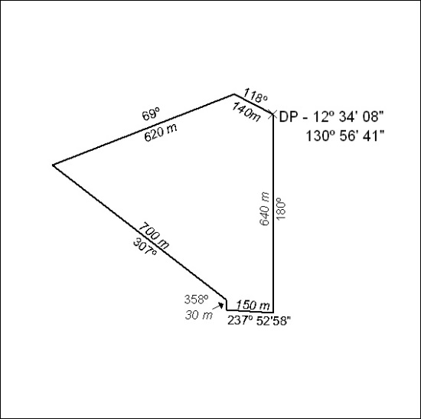

479/18

Mineral Titles Act
NOTICE OF LAND CEASING TO BE A MINERAL TITLE
Title Type and Number: | Mineral Authority 512
Area ceased on: | 24 October 2018
Area: | 33.00 Hectare
Locality: | BYNOE
Name of Applicants(s)Holder(s): | 100% A AND SF MADDALOZZO PTY. LIMITED [ACN. 009 624 015]
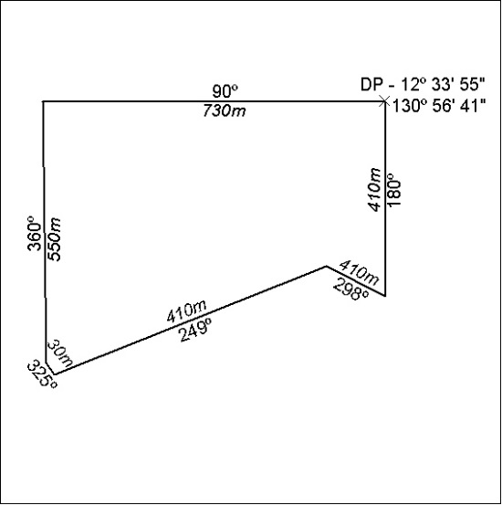

480/18

