Mineral Titles Act
NOTICE OF LAND CEASING TO BE A MINERAL TITLE AREA
Title Type and Number: | Exploration Licence 29920
Area Ceased on: | 01 October 2018
Area: | 4 Blocks, 10.03 km²
Locality: | QUARTZ
Name of Applicant(s)/Holder(s): | 100% BARFUSS CORPORATION PTY. LTD. [ACN. 006 917 666]
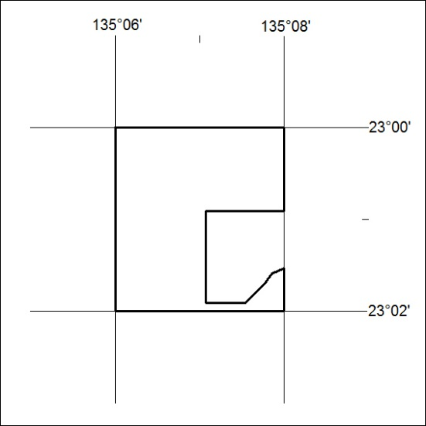

420/18

Mineral Titles Act
NOTICE OF LAND CEASING TO BE A MINERAL TITLE AREA
Title Type and Number: | Exploration Licence 29950
Area Ceased on: | 01 October 2018
Area: | 61 Blocks, 192.67 km²
Locality: | QUARTZ
Name of Applicant(s)/Holder(s): | 100% BARFUSS CORPORATION PTY. LTD. [ACN. 006 917 666]
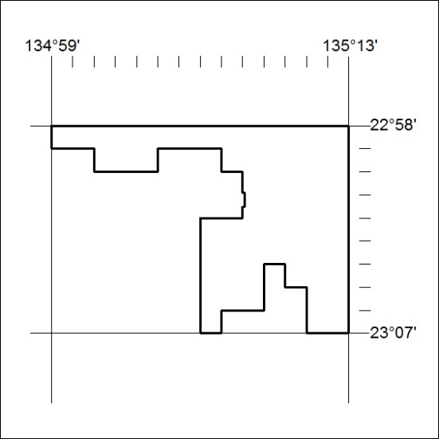

421/18

