Mineral Titles Act
NOTICE OF LAND CEASING TO BE A MINERAL TITLE
Title Type and Number: | Extractive Mineral Permit 25678
Area ceased on: | 23 August 2018
Area: | 65.00 Hectare
Locality: | REYNOLDS RIVER
Name of Applicants(s)Holder(s): | 100% MCKINNON TRANSPORT PTY LTD [ACN. 054 373 376]
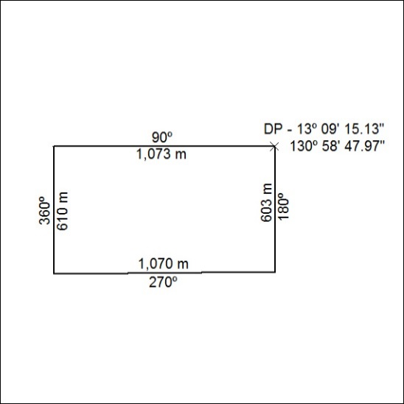

355/18

Mineral Titles Act
NOTICE OF GRANT OF A MINERAL TITLE
Title Type and Number: | Exploration Licence 31801
Granted: | 22 August 2018, for a period of 6 Years
Area: | 242 Blocks, 752.56 km²
Locality: | MITCHIEBO
Name of Holder/s: | 100% MMG EXPLORATION PTY LTD* [ACN. 119 136 659]
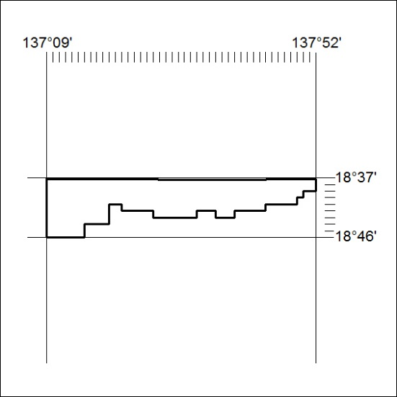
Area granted is indicated above. The titleholder is not permitted to exercise occupational rights on any land that is subject to a development title, or an application for a development title. Any land the subject of a Reserved Land gazettal under the Mineral Titles Act and all land vested in the Commonwealth of Australia is also excluded by description but not excised from the grant area.

356/18

Mineral Titles Act
NOTICE OF GRANT OF A MINERAL TITLE
Title Type and Number: | Exploration Licence 31802
Granted: | 22 August 2018, for a period of 6 Years
Area: | 232 Blocks, 753.37 km²
Locality: | MITTIEBAH
Name of Holder/s: | 100% MMG EXPLORATION PTY LTD* [ACN. 119 136 659]
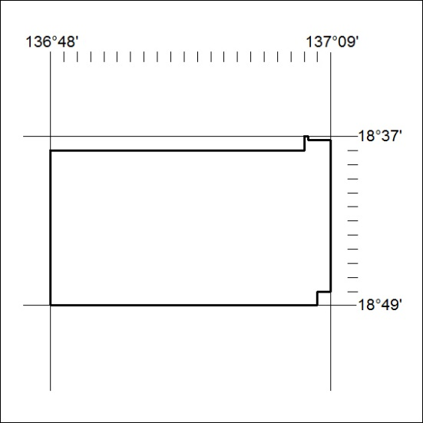
Area granted is indicated above. The titleholder is not permitted to exercise occupational rights on any land that is subject to a development title, or an application for a development title. Any land the subject of a Reserved Land gazettal under the Mineral Titles Act and all land vested in the Commonwealth of Australia is also excluded by description but not excised from the grant area.

357/18

