Mineral Titles Act
NOTICE OF LAND CEASING TO BE A MINERAL TITLE
Title Type and Number: | Extractive Mineral Permit 23317
Area ceased on: | 02 August 2018
Area: | 4.00 Hectare
Locality: | KATHERINE
Name of Applicants(s)Holder(s): | 100% HOLT Robert
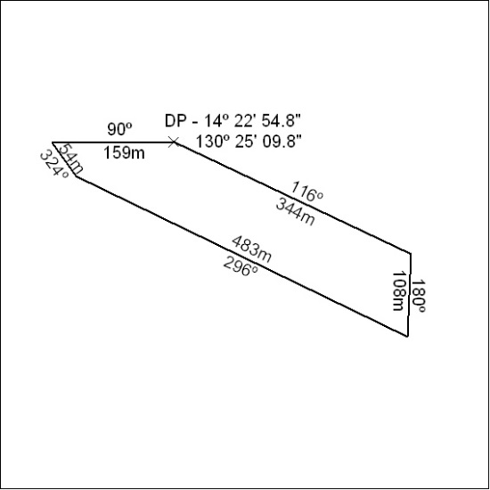

338/18

Mineral Titles Act
NOTICE OF LAND CEASING TO BE A MINERAL TITLE AREA
Title Type and Number: | Exploration Licence 27737
Area Ceased on: | 03 August 2018
Area: | 4 Blocks, 13.11 km²
Locality: | CALVERT HILLS
Name of Applicant(s)/Holder(s): | 100% REDBANK OPERATIONS PTY LTD* [ACN. 109 362 165]
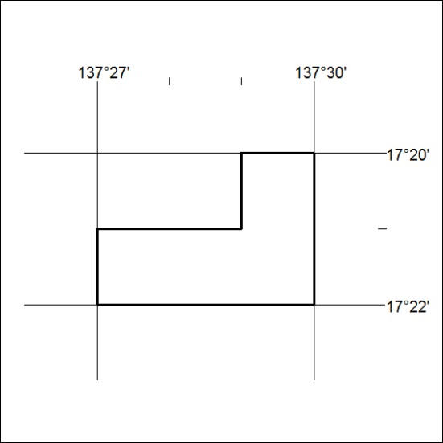

339/18

Mineral Titles Act
NOTICE OF GRANT OF A MINERAL TITLE
Title Type and Number: | Exploration Licence 31761
Granted: | 02 August 2018, for a period of 6 Years
Area: | 250 Blocks, 823.79 km²
Locality: | ROBINSON
Name of Holder/s: | 100% NOMAD EXPLORATIONS PTY LTD [ACN. 622 780 027]
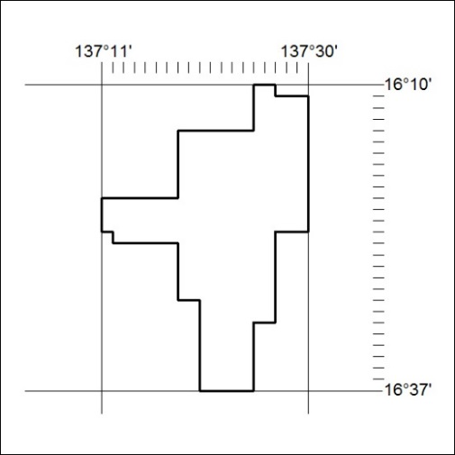
Area granted is indicated above. The titleholder is not permitted to exercise occupational rights on any land that is subject to a development title, or an application for a development title. Any land the subject of a Reserved Land gazettal under the Mineral Titles Act and all land vested in the Commonwealth of Australia is also excluded by description but not excised from the grant area.

340/18

