Mineral Titles Act
NOTICE OF LAND CEASING TO BE A MINERAL TITLE
Title Type and Number: | Mineral Lease 30176
Area ceased on: | 10 July 2018
Area: | 144.00 Hectares
Locality: | FLYNN
Name of Applicants(s)Holder(s): | 100% SANTEXCO PTY LTD [ACN. 002 910 296]
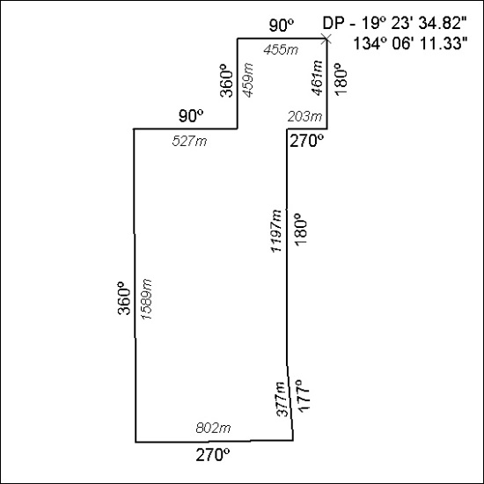

294/18

Mineral Titles Act
NOTICE OF LAND CEASING TO BE A MINERAL TITLE
Title Type and Number: | Mineral Lease 30815
Area ceased on: | 10 July 2018
Area: | 29.00 Hectare
Locality: | TENNANT CREEK
Name of Applicants(s)Holder(s): | 100% GIANTS REEF EXPLORATION PTY LTD* [ACN. 009 200 346]
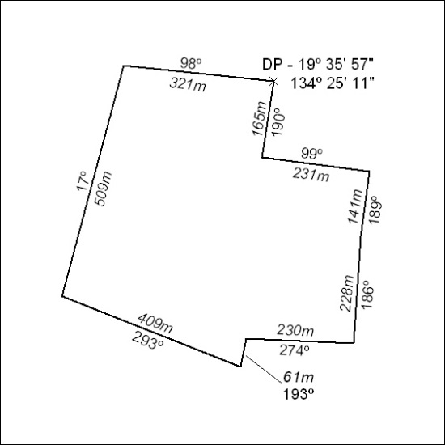

295/18

Mineral Titles Act
NOTICE OF LAND CEASING TO BE A MINERAL TITLE AREA
Title Type and Number: | Exploration Licence 30302
Area Ceased on: | 09 July 2018
Area: | 113 Blocks, 372.31 km²
Locality: | ADAM
Name of Applicant(s)/Holder(s): | 100% SANDFIRE RESOURCES NL [ACN. 105 154 185]
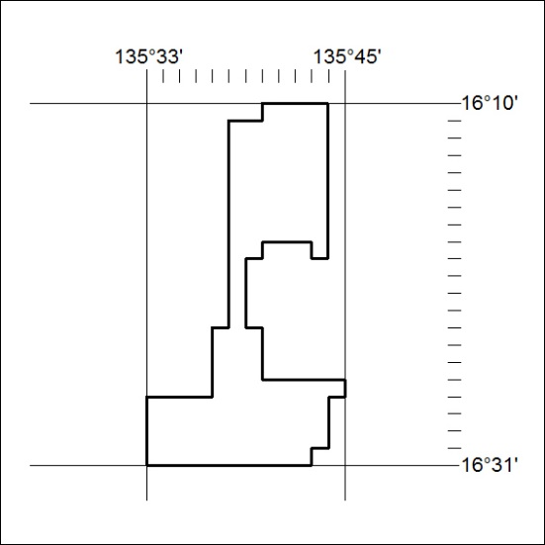

296/18

Mineral Titles Act
NOTICE OF LAND CEASING TO BE A MINERAL TITLE AREA
Title Type and Number: | Exploration Licence 31903
Area Ceased on: | 06 July 2018
Area: | 2 Blocks, 6.69 km²
Locality: | BATCHELOR
Name of Applicant(s)/Holder(s): | 100% BACCHUS RESOURCES PTY LTD [ACN. 606 340 872]
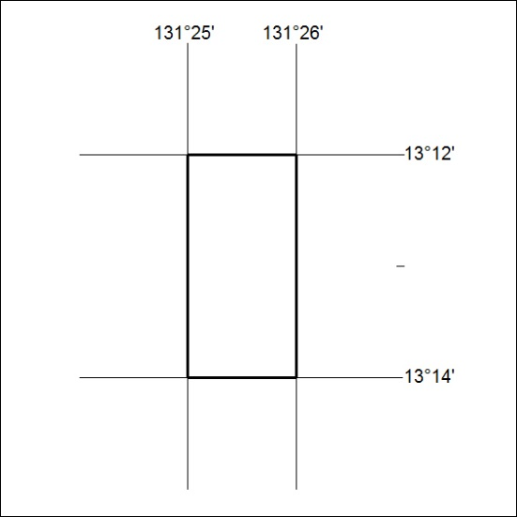

297/18

Mineral Titles Act
NOTICE OF LAND CEASING TO BE A MINERAL TITLE AREA
Title Type and Number: | Exploration Licence 31904
Area Ceased on: | 06 July 2018
Area: | 2 Blocks, 6.69 km²
Locality: | BATCHELOR
Name of Applicant(s)/Holder(s): | 100% PNX METALS LIMITED* [ACN. 127 446 271]
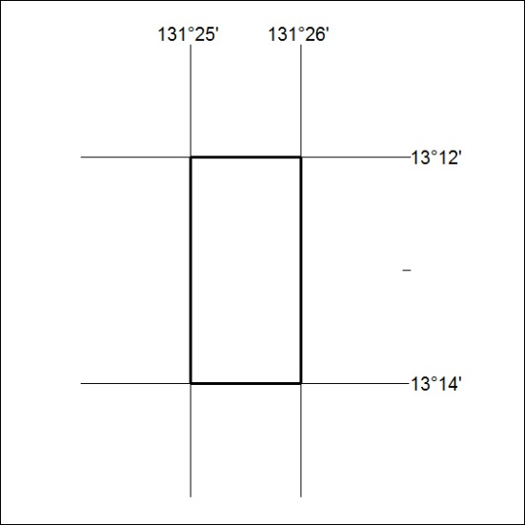

298/18

