Mineral Titles Act
NOTICE OF GRANT OF A MINERAL TITLE
Title Type and Number: | Extractive Mineral Permit 31515
Granted: | 26 June 2018, for a period of 5 Years
Area: | 5.56 Hectares
Locality: | BICKERTON
Name of Holder/s: | 100% GEBIE CIVIL AND CONSTRUCTION PTY LTD [ACN. 144 955 528]
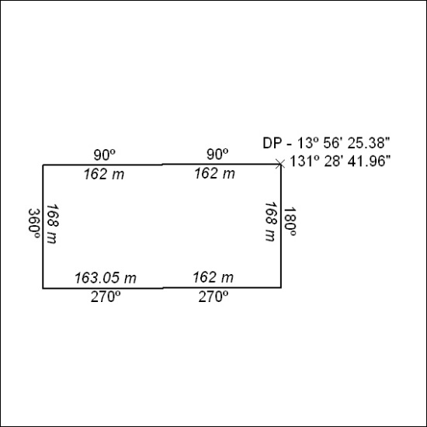

281/18

