Mineral Titles Act
NOTICE OF LAND CEASING TO BE A MINERAL TITLE AREA
Title Type and Number: | Exploration Licence 30039
Area Ceased on: | 31 May 2018
Area: | 31 Blocks, 103.35 km²
Locality: | DALY RIVER
Name of Applicant(s)/Holder(s): | 100% ARGECO PTY LTD [ACN. 122 153 271]
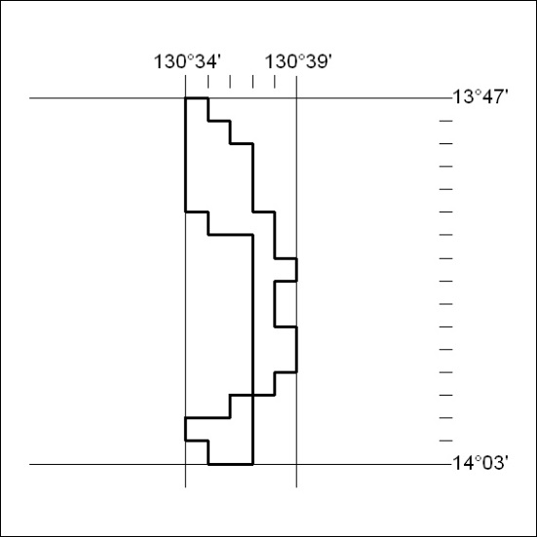

220/18

Mineral Titles Act
NOTICE OF LAND CEASING TO BE A MINERAL TITLE AREA
Title Type and Number: | Extractive Mineral Exploration Licence 31060
Area Ceased on: | 31 May 2018
Area: | 4 Blocks, 12.69 km²
Locality: | KATHERINE
Name of Applicant(s)/Holder(s): | 100% ENDEAVOUR INVESTMENTS (NT) PTY LTD [ACN. 133 112 811]
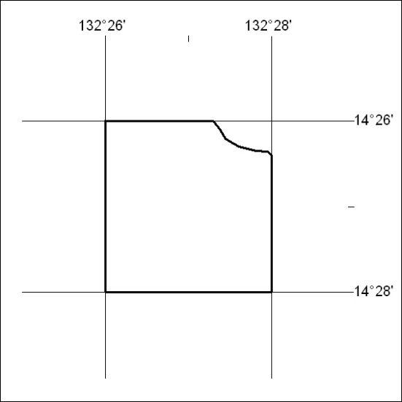

221/18

Mineral Titles Act
NOTICE OF LAND CEASING TO BE A MINERAL TITLE AREA
Title Type and Number: | Extractive Mineral Exploration Licence 31061
Area Ceased on: | 31 May 2018
Area: | 4 Blocks, 13.30 km²
Locality: | KATHERINE
Name of Applicant(s)/Holder(s): | 100% ENDEAVOUR INVESTMENTS (NT) PTY LTD [ACN. 133 112 811]
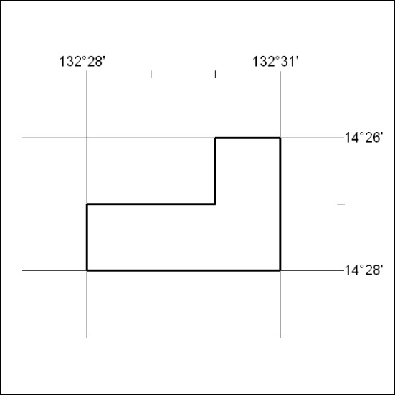

222/18

Mineral Titles Act
NOTICE OF LAND CEASING TO BE A MINERAL TITLE AREA
Title Type and Number: | Extractive Mineral Exploration Licence 31062
Area Ceased on: | 31 May 2018
Area: | 4 Blocks, 13.30 km²
Locality: | KATHERINE
Name of Applicant(s)/Holder(s): | 100% ENDEAVOUR INVESTMENTS (NT) PTY LTD [ACN. 133 112 811]
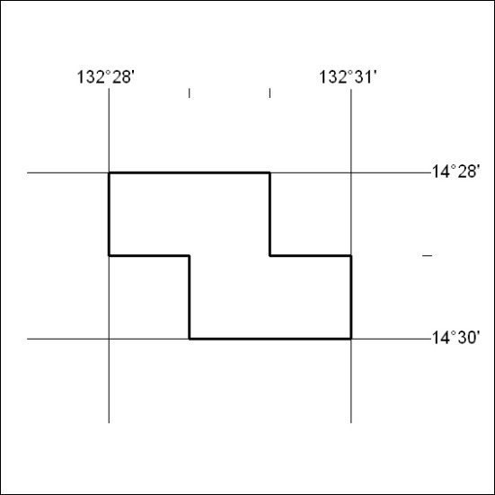

223/18

Mineral Titles Act
NOTICE OF LAND CEASING TO BE A MINERAL TITLE AREA
Title Type and Number: | Extractive Mineral Exploration Licence 31085
Area Ceased on: | 31 May 2018
Area: | 4 Blocks, 3.62 km²
Locality: | MANBULLOO
Name of Applicant(s)/Holder(s): | 100% ENDEAVOUR INVESTMENTS (NT) PTY LTD [ACN. 133 112 811]
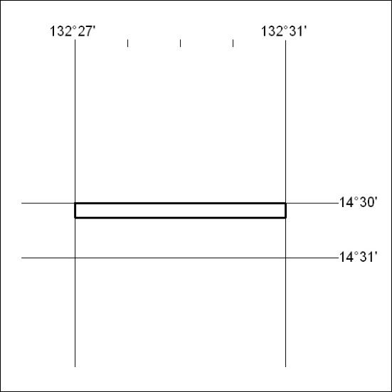

224/18

Mineral Titles Act
NOTICE OF LAND CEASING TO BE A MINERAL TITLE AREA
Title Type and Number: | Extractive Mineral Exploration Licence 31086
Area Ceased on: | 31 May 2018
Area: | 4 Blocks, 13.30 km²
Locality: | KATHERINE
Name of Applicant(s)/Holder(s): | 100% ENDEAVOUR INVESTMENTS (NT) PTY LTD [ACN. 133 112 811]
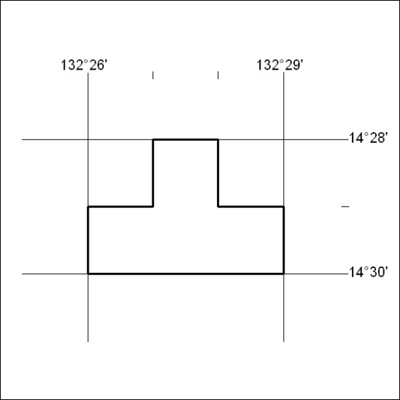

225/18

Corrigendum
Notice Number 217 appearing in MN70/18 on 30 May 2018 is hereby cancelled and replaced by the following:

Mineral Titles Act
NOTICE OF LAND CEASING TO BE A MINERAL TITLE AREA
Title Type and Number: | Exploration Licence 28795
Area Ceased on: | 29 May 2018
Area: | 2 Blocks, 6.30 km²
Locality: | ANBURLA
Name of Applicant(s)/Holder(s): | 56.28% CROSSLAND NICKEL PTY LTD* [ACN. 099 477 915], 43.72% ESSENTIAL MINING RESOURCES PTY LTD [ACN. 601 655 725]
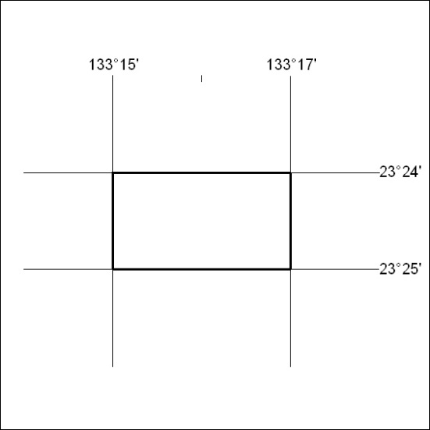

226/18

