Mineral Titles Act
NOTICE OF LAND CEASING TO BE A MINERAL TITLE
Title Type and Number: | Extractive Mineral Permit 27497
Area ceased on: | 29 May 2018
Area: | 40.00 Hectare
Locality: | KOOLPINYAH
Name of Applicants(s)Holder(s): | 100% BORAL RESOURCES (QLD) PTY LIMITED [ACN. 009 671 809]
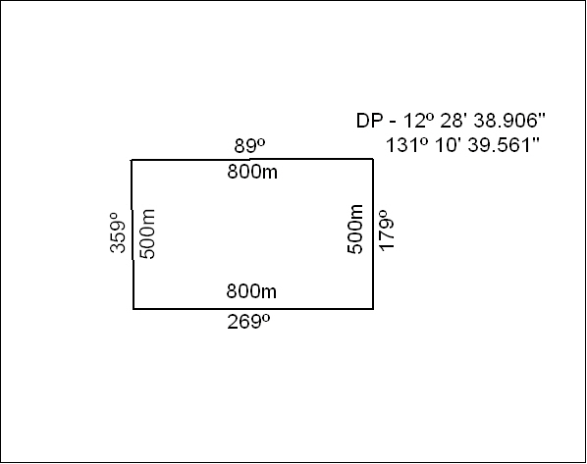

207/18

Mineral Titles Act
NOTICE OF LAND CEASING TO BE A MINERAL TITLE
Title Type and Number: | Extractive Mineral Permit 27556
Area ceased on: | 29 May 2018
Area: | 40.00 Hectare
Locality: | KOOLPINYAH
Name of Applicants(s)Holder(s): | 100% BORAL RESOURCES (QLD) PTY LIMITED [ACN. 009 671 809]
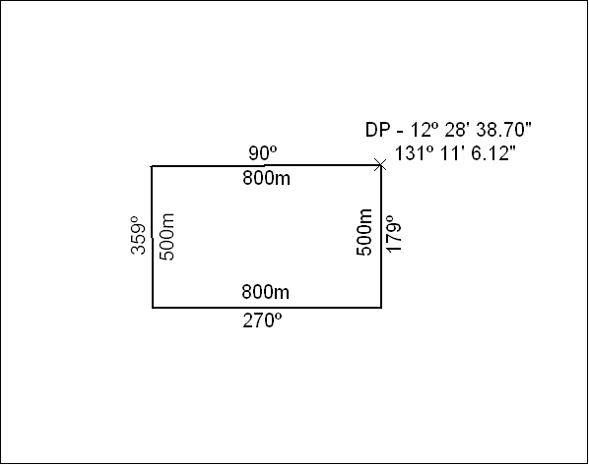

208/18

Mineral Titles Act
NOTICE OF GRANT OF A MINERAL TITLE
Title Type and Number: | Extractive Mineral Permit 31643
Granted: | 25 May 2018, for a period of 5 Years
Area: | 28.00 Hectares
Locality: | KOOLPINYAH
Name of Holder/s: | 100% MOUSELLIS & SONS PTY. LTD. [ACN. 009 654 791]
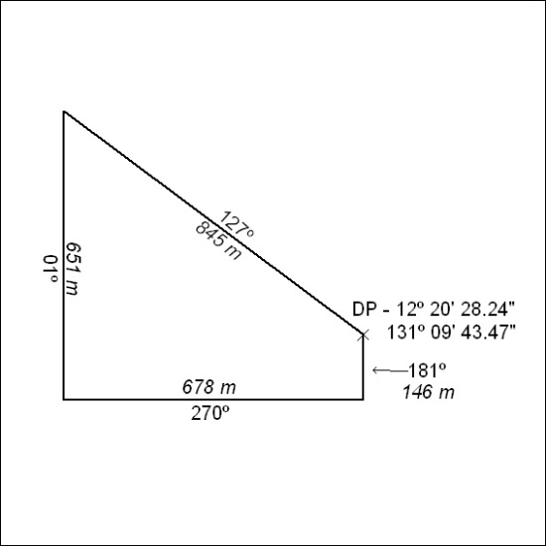

209/18

Mineral Titles Act
NOTICE OF GRANT OF A MINERAL TITLE
Title Type and Number: | Extractive Mineral Permit 31644
Granted: | 25 May 2018, for a period of 5 Years
Area: | 21.98 Hectares
Locality: | KOOLPINYAH
Name of Holder/s: | 100% MOUSELLIS & SONS PTY. LTD. [ACN. 009 654 791]
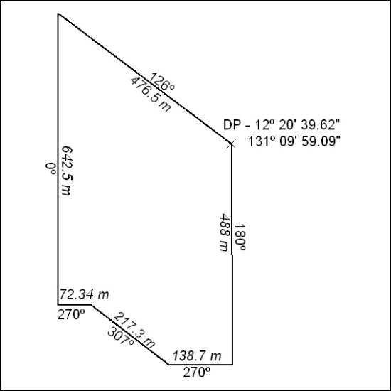

210/18

Mineral Titles Act
NOTICE OF GRANT OF A MINERAL TITLE
Title Type and Number: | Extractive Mineral Permit 31645
Granted: | 25 May 2018, for a period of 5 Years
Area: | 41.91 Hectares
Locality: | KOOLPINYAH
Name of Holder/s: | 100% MOUSELLIS & SONS PTY. LTD. [ACN. 009 654 791]
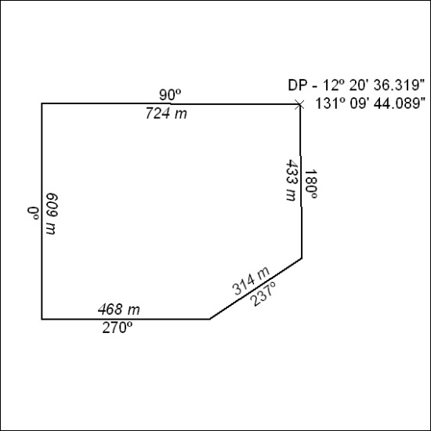

211/18

Mineral Titles Act
NOTICE OF GRANT OF A MINERAL TITLE
Title Type and Number: | Extractive Mineral Permit 31647
Granted: | 25 May 2018, for a period of 5 Years
Area: | 53.83 Hectares
Locality: | KOOLPINYAH
Name of Holder/s: | 100% JN. MOUSELLIS CIVIL CONTRACTORS PTY LTD [ACN. 122 603 990]
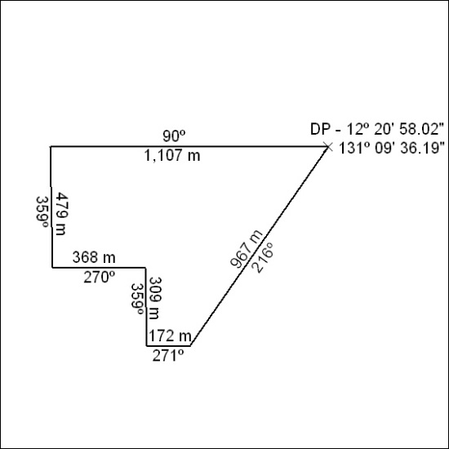

212/18

Mineral Titles Act
NOTICE OF GRANT OF A MINERAL TITLE
Title Type and Number: | Extractive Mineral Permit 31648
Granted: | 25 May 2018, for a period of 5 Years
Area: | 41.73 Hectares
Locality: | KOOLPINYAH
Name of Holder/s: | 100% JN. MOUSELLIS CIVIL CONTRACTORS PTY LTD [ACN. 122 603 990]
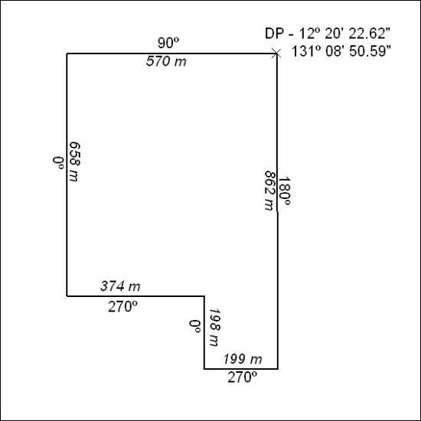

213/18

Mineral Titles Act
NOTICE OF GRANT OF A MINERAL TITLE
Title Type and Number: | Extractive Mineral Permit 31649
Granted: | 25 May 2018, for a period of 5 Years
Area: | 43.60 Hectares
Locality: | KOOLPINYAH
Name of Holder/s: | 100% JN. MOUSELLIS CIVIL CONTRACTORS PTY LTD [ACN. 122 603 990]
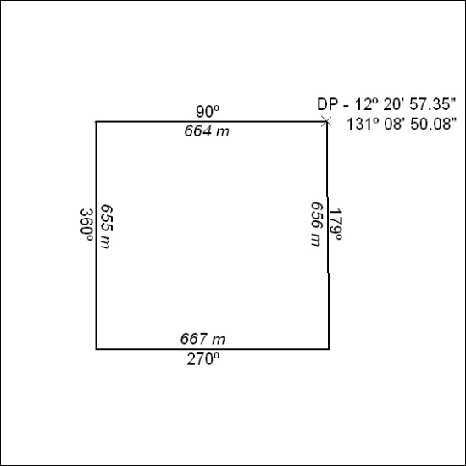

214/18

Mineral Titles Act
NOTICE OF GRANT OF A MINERAL TITLE
Title Type and Number: | Extractive Mineral Permit 31661
Granted: | 25 May 2018, for a period of 5 Years
Area: | 43.87 Hectares
Locality: | KOOLPINYAH
Name of Holder/s: | 100% MOUSELLIS & SONS PTY. LTD. [ACN. 009 654 791]
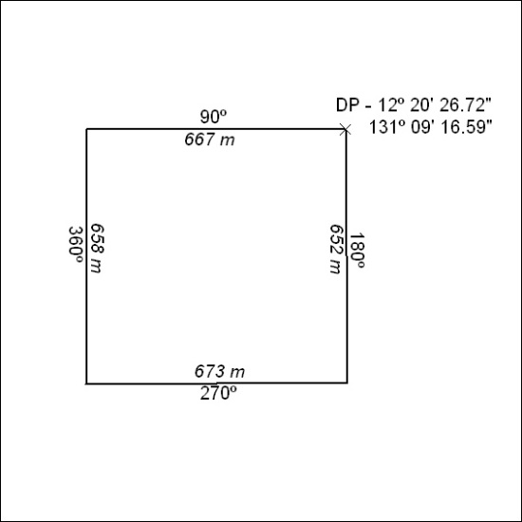

215/18

Mineral Titles Act
NOTICE OF GRANT OF A MINERAL TITLE
Title Type and Number: | Extractive Mineral Permit 31662
Granted: | 25 May 2018, for a period of 5 Years
Area: | 39.38 Hectares
Locality: | KOOLPINYAH
Name of Holder/s: | 100% JN. MOUSELLIS CIVIL CONTRACTORS PTY LTD [ACN. 122 603 990]
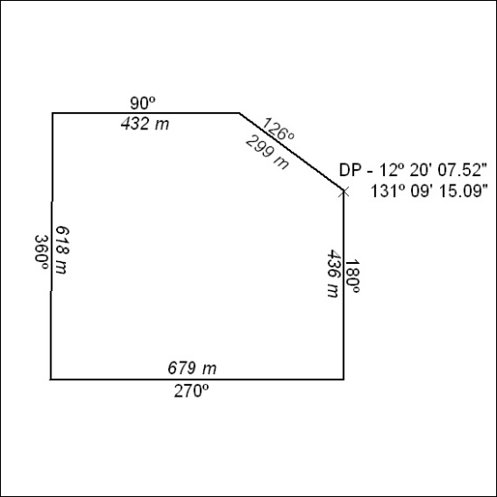

216/18

