Mineral Titles Act 2010
NOTICE OF LAND CEASING TO BE A MINERAL TITLE AREA
Title Type and Number: | Mineral Authority 364
Area ceased on: | 30 November 2022
Area: | 349.00 Hectares
Locality: | BYNOE
Name of Applicants(s)Holder(s): | 100% NORTHERN TERRITORIES RESOURCES PTY LTD* [ACN. 124 647 829]
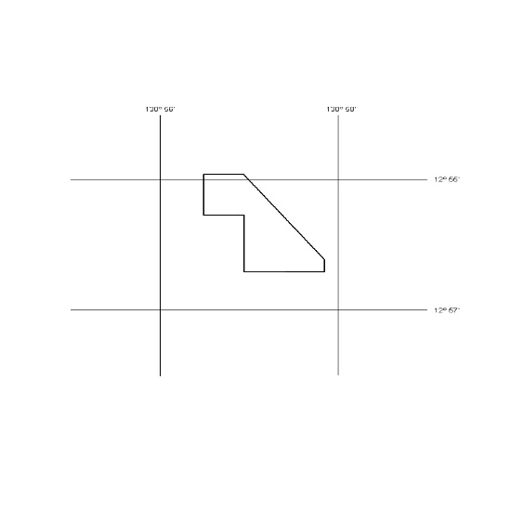

416/22

