Mineral Titles Act
NOTICE OF GRANT OF A MINERAL TITLE
Title Type and Number: | Exploration Licence 33045
Granted: | 24 November 2022, for a period of 6 Years
Area: | 90 Blocks, 296.66 km²
Locality: | NEWRY
Name of Holder/s: | 100% ROSEWOOD MINERALS PTY LTD [ACN. 653 271 179]
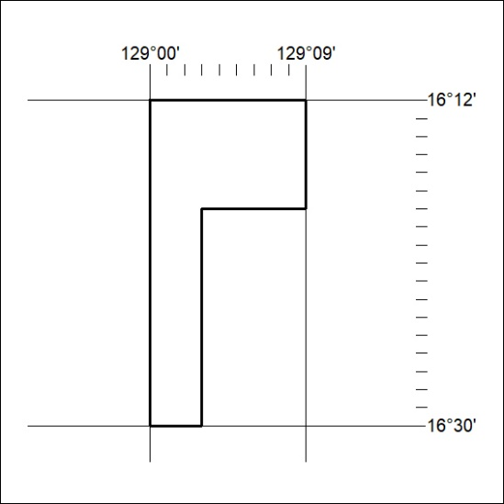
Area granted is indicated above. The titleholder is not permitted to exercise occupational rights on any land that is subject to a development title, or an application for a development title. Any land the subject of a Reserved Land gazettal under the Mineral Titles Act and all land vested in the Commonwealth of Australia is also excluded by description but not excised from the grant area.

412/22

