Mineral Titles Act
NOTICE OF GRANT OF A MINERAL TITLE
Title Type and Number: | Exploration Licence 33070
Granted: | 04 November 2022, for a period of 6 Years
Area: | 36 Blocks, 106.33 km²
Locality: | ELSEY
Name of Holder/s: | 100% FIDDLER'S CREEK MINING COMPANY PTY LTD * [ACN. 099 215 648]
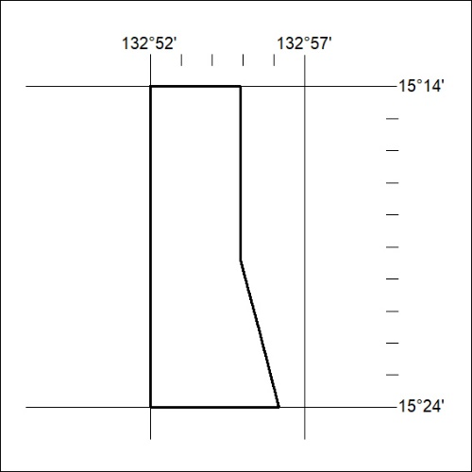
Area granted is indicated above. The titleholder is not permitted to exercise occupational rights on any land that is subject to a development title, or an application for a development title. Any land the subject of a Reserved Land gazettal under the Mineral Titles Act and all land vested in the Commonwealth of Australia is also excluded by description but not excised from the grant area.

375/22

Mineral Titles Act
NOTICE OF GRANT OF A MINERAL TITLE
Title Type and Number: | Exploration Licence 33086
Granted: | 03 November 2022, for a period of 6 Years
Area: | 249 Blocks, 815.60 km²
Locality: | LIMBUNYA
Name of Holder/s: | 100% TRANSITION MINERALS LIMITED* [ACN. 641 565 139]
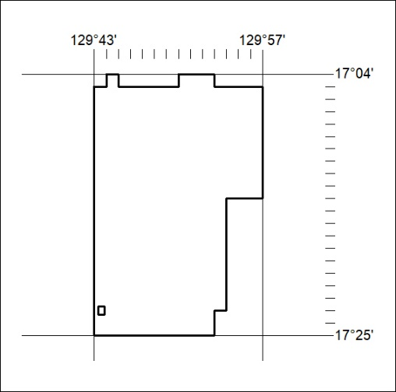
Area granted is indicated above. The titleholder is not permitted to exercise occupational rights on any land that is subject to a development title, or an application for a development title. Any land the subject of a Reserved Land gazettal under the Mineral Titles Act and all land vested in the Commonwealth of Australia is also excluded by description but not excised from the grant area.

376/22

Mineral Titles Act
NOTICE OF GRANT OF A MINERAL TITLE
Title Type and Number: | Exploration Licence 33087
Granted: | 03 November 2022, for a period of 6 Years
Area: | 249 Blocks, 816.91 km²
Locality: | LIMBUNYA
Name of Holder/s: | 100% TRANSITION MINERALS LIMITED* [ACN. 641 565 139]
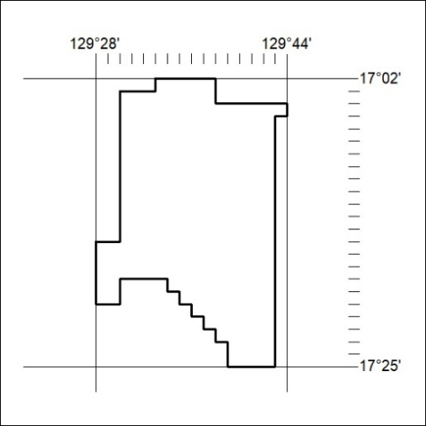
Area granted is indicated above. The titleholder is not permitted to exercise occupational rights on any land that is subject to a development title, or an application for a development title. Any land the subject of a Reserved Land gazettal under the Mineral Titles Act and all land vested in the Commonwealth of Australia is also excluded by description but not excised from the grant area.

377/22

Mineral Titles Act
NOTICE OF GRANT OF A MINERAL TITLE
Title Type and Number: | Exploration Licence 33162
Granted: | 03 November 2022, for a period of 6 Years
Area: | 37 Blocks, 116.07 km²
Locality: | NAPIER
Name of Holder/s: | 100% TRANSITION MINERALS LIMITED* [ACN. 641 565 139]
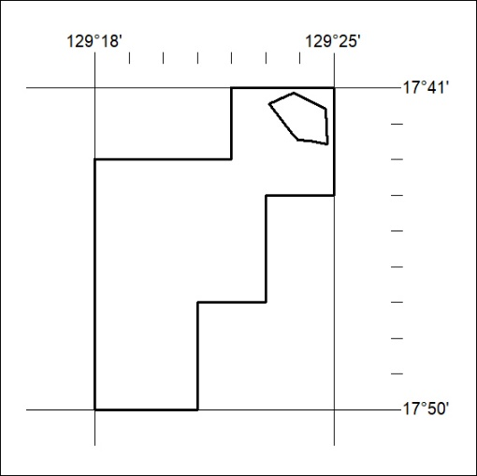
Area granted is indicated above. The titleholder is not permitted to exercise occupational rights on any land that is subject to a development title, or an application for a development title. Any land the subject of a Reserved Land gazettal under the Mineral Titles Act and all land vested in the Commonwealth of Australia is also excluded by description but not excised from the grant area.

378/22
Mineral Titles Act 2010
NOTICE OF LAND CEASING TO BE A MINERAL TITLE AREA
Title Type and Number: | Extractive Mineral Exploration Licence 32371
Area Ceased on: | 05 November 2022
Area: | 4 Blocks, 13.16 km²
Locality: | MALLAPUNYAH
Name of Applicant(s)/Holder(s): | 100% EAST ARM CIVIL PTY LTD [ACN. 073 382 251]
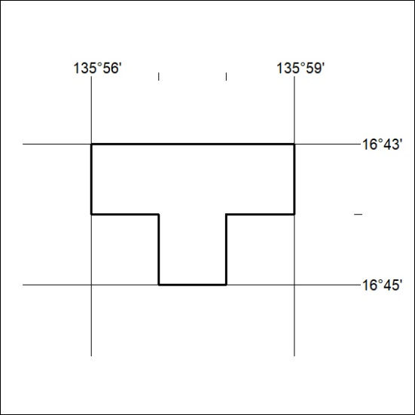

379/22

Mineral Titles Act 2010
NOTICE OF LAND CEASING TO BE A MINERAL TITLE AREA
Title Type and Number: | Extractive Mineral Exploration Licence 32372
Area Ceased on: | 05 November 2022
Area: | 4 Blocks, 13.15 km²
Locality: | MALLAPUNYAH
Name of Applicant(s)/Holder(s): | 100% EAST ARM CIVIL PTY LTD [ACN. 073 382 251]
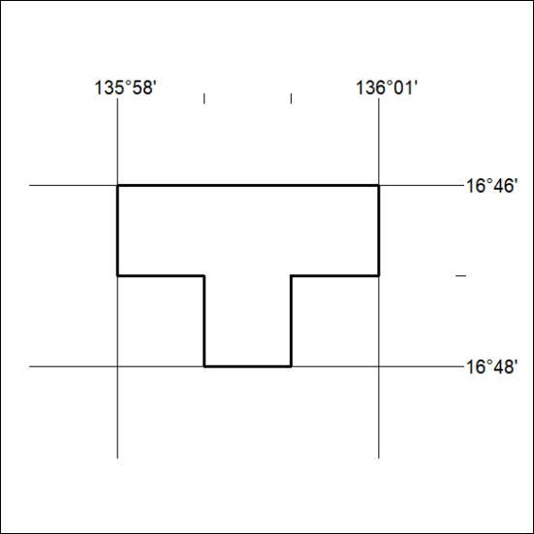

380/22
Mineral Titles Act 2010
NOTICE OF LAND CEASING TO BE A MINERAL TITLE AREA
Title Type and Number: | Extractive Mineral Exploration Licence 32373
Area Ceased on: | 05 November 2022
Area: | 4 Blocks, 13.15 km²
Locality: | GLYDE
Name of Applicant(s)/Holder(s): | 100% EAST ARM CIVIL PTY LTD [ACN. 073 382 251]
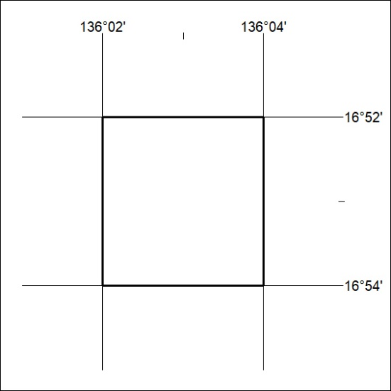

381/22

Mineral Titles Act
NOTICE OF GRANT OF A MINERAL TITLE
Title Type and Number: | Exploration Licence 33121
Granted: | 04 November 2022, for a period of 6 Years
Area: | 4 Blocks, 12.90 km²
Locality: | BONNEY
Name of Holder/s: | 100% CASTILE RESOURCES LTD* [ACN. 124 314 085]
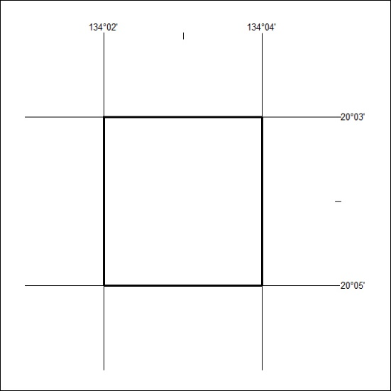
Area granted is indicated above. The titleholder is not permitted to exercise occupational rights on any land that is subject to a development title, or an application for a development title. Any land the subject of a Reserved Land gazettal under the Mineral Titles Act and all land vested in the Commonwealth of Australia is also excluded by description but not excised from the grant area.

382/22

Mineral Titles Act
NOTICE OF GRANT OF A MINERAL TITLE
Title Type and Number: | Exploration Licence 33195
Granted: | 07 November 2022, for a period of 6 Years
Area: | 43 Blocks, 136.60 km²
Locality: | VAUGHAN
Name of Holder/s: | 100% GSW RESOURCES PTY LTD [ACN. 653 791 130]
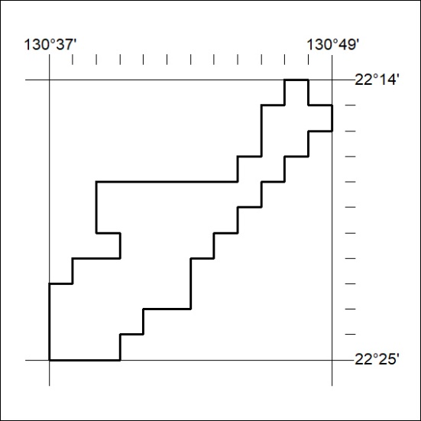
Area granted is indicated above. The titleholder is not permitted to exercise occupational rights on any land that is subject to a development title, or an application for a development title. Any land the subject of a Reserved Land gazettal under the Mineral Titles Act and all land vested in the Commonwealth of Australia is also excluded by description but not excised from the grant area.

383/22

