Mineral Titles Act 2010
NOTICE OF LAND CEASING TO BE A MINERAL TITLE AREA
Title Type and Number: | Extractive Mineral Permit 30557
Area ceased on: | 14 October 2022
Area: | 71.00 Hectare
Locality: | NEWRY
Name of Applicants(s)Holder(s): | 100% DUNCAN Ruth Ann
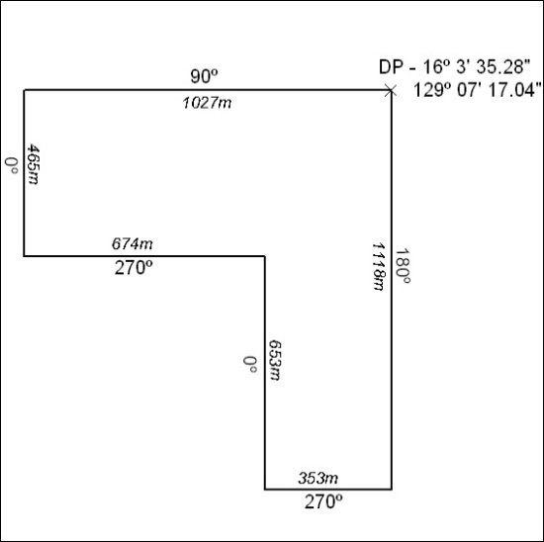

353/22

Mineral Titles Act
NOTICE OF GRANT OF A MINERAL TITLE
Title Type and Number: | Exploration Licence 32958
Granted: | 14 October 2022, for a period of 6 Years
Area: | 66 Blocks, 165.92 km²
Locality: | RIDDOCH
Name of Holder/s: | 100% IGO NEWSEARCH PTY LTD [ACN. 142 192 701]
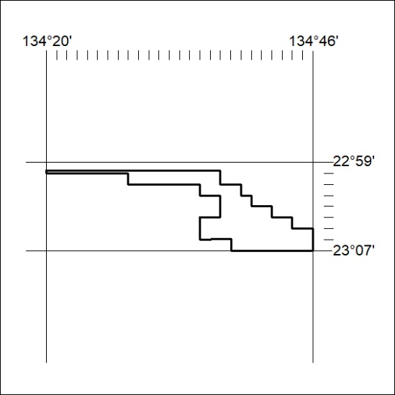
Area granted is indicated above. The titleholder is not permitted to exercise occupational rights on any land that is subject to a development title, or an application for a development title. Any land the subject of a Reserved Land gazettal under the Mineral Titles Act and all land vested in the Commonwealth of Australia is also excluded by description but not excised from the grant area.

354/22

Mineral Titles Act
NOTICE OF GRANT OF A MINERAL TITLE
Title Type and Number: | Extractive Mineral Permit 32803
Granted: | 17 October 2022, for a period of 5 Years
Area: | 90.00 Hectares
Locality: | EVA VALLEY
Name of Holder/s: | 66% D&S SAND, SOIL & GRAVEL PTY LTD [ACN. 645 168 752], 34% TEELOW Leslie John
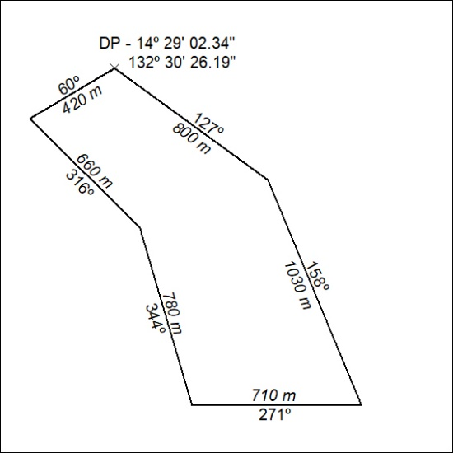

355/22

