Mineral Titles Act 2010
NOTICE OF LAND CEASING TO BE A MINERAL TITLE AREA
Title Type and Number: | Exploration Licence 32664
Area Ceased on: | 14 October 2022
Area: | 38 Blocks, 117.73 km²
Locality: | RIDDOCH
Name of Applicant(s)/Holder(s): | 100% COMET RESOURCES LIMITED [ACN. 060 628 202]
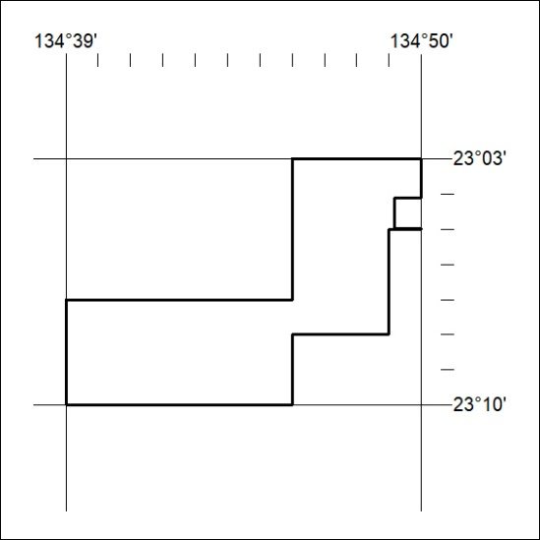

352/22

