Mineral Titles Act 2010
NOTICE OF LAND CEASING TO BE A MINERAL TITLE APPLICATION AREA
Title Type and Number: | Exploration Licence 33139
Area Ceased on: | 05 October 2022
Area: | 53 Blocks, 166.28 km²
Locality: | QUARTZ
Name of Applicant(s)/Holder(s): | 100% PEREGIAN MINERALS PTY LTD [ACN. 656 661 586]
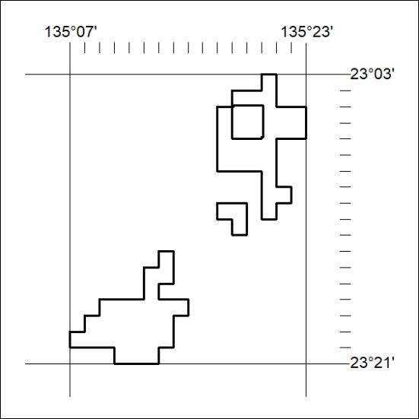

348/22

Mineral Titles Act 2010
NOTICE OF LAND CEASING TO BE A MINERAL TITLE APPLICATION AREA
Title Type and Number: | Exploration Licence 33140
Area Ceased on: | 05 October 2022
Area: | 27 Blocks, 85.27 km²
Locality: | QUARTZ
Name of Applicant(s)/Holder(s): | 100% PEREGIAN MINERALS PTY LTD [ACN. 656 661 586]
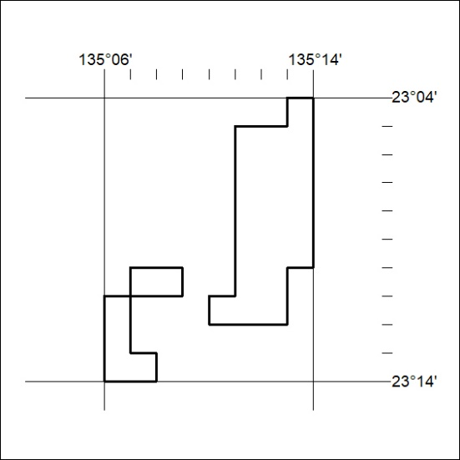

349/22

Mineral Titles Act
NOTICE OF GRANT OF A MINERAL TITLE
Title Type and Number: | Exploration Licence 33161
Granted: | 07 October 2022, for a period of 6 Years
Area: | 248 Blocks, 782.80 km²
Locality: | ANSON
Name of Holder/s: | 100% STRATEGIC EXPLORATION PTY LTD [ACN. 657 519 830]
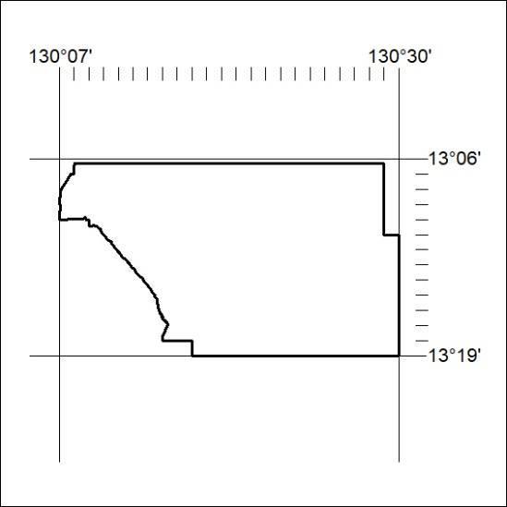
Area granted is indicated above. The titleholder is not permitted to exercise occupational rights on any land that is subject to a development title, or an application for a development title. Any land the subject of a Reserved Land gazettal under the Mineral Titles Act and all land vested in the Commonwealth of Australia is also excluded by description but not excised from the grant area.

350/22

