Mineral Titles Act 2010
NOTICE OF LAND CEASING TO BE A MINERAL TITLE AREA
Title Type and Number: | Exploration Licence 30730
Area Ceased on: | 26 September 2022
Area: | 66 Blocks, 208.74 km²
Locality: | CAREY
Name of Applicant(s)/Holder(s): | 100% PRODIGY GOLD NL* [ACN. 009 127 020]
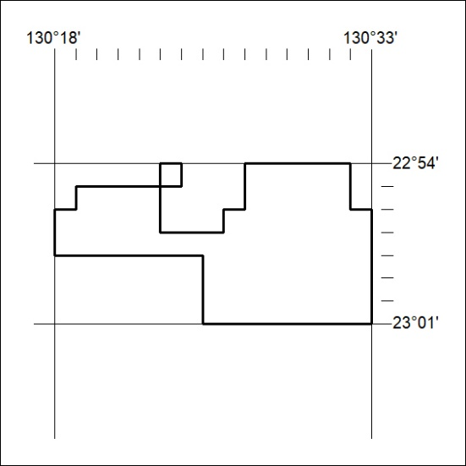

341/22

