Mineral Titles Act 2010
NOTICE OF LAND CEASING TO BE A MINERAL TITLE AREA
Title Type and Number: | Exploration Licence 32510
Area Ceased on: | 02 June 2022
Area: | 249 Blocks, 793.41 km²
Locality: | BARWOLLA
Name of Applicant(s)/Holder(s): | 100% MINERALS PTY LTD [ACN. 641 565 139]
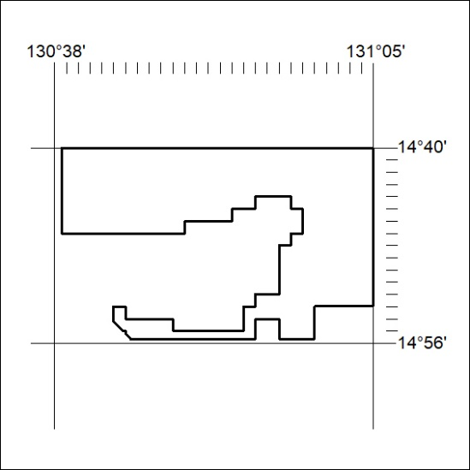

173/22

Mineral Titles Act 2010
NOTICE OF LAND CEASING TO BE A MINERAL TITLE AREA
Title Type and Number: | Extractive Mineral Permit 25853
Area ceased on: | 02 June 2022
Area: | 9.00 Hectare
Locality: | BYNOE
Name of Applicants(s)Holder(s): | 100% MOUSELLIS John Nick
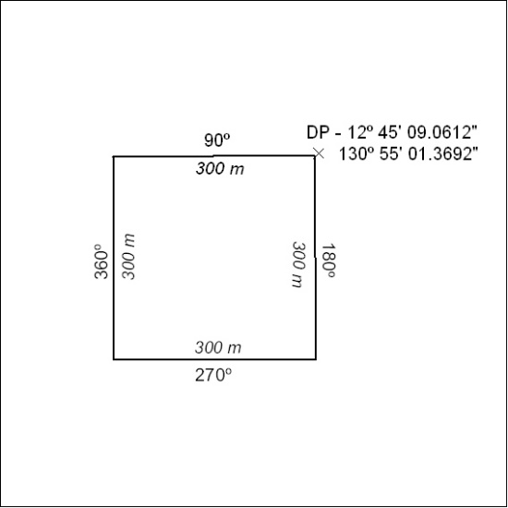

174/22

Mineral Titles Act 2010
NOTICE OF LAND CEASING TO BE A MINERAL TITLE AREA
Title Type and Number: | Extractive Mineral Permit 25854
Area ceased on: | 02 June 2022
Area: | 2.00 Hectare
Locality: | KOOLPINYAH
Name of Applicants(s)Holder(s): | 100% MOUSELLIS John Nick
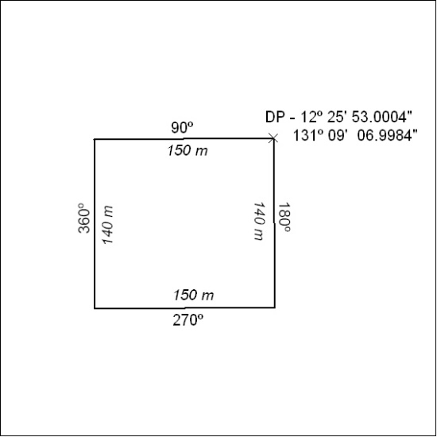

175/22

