Mineral Titles Act
NOTICE OF GRANT OF A MINERAL TITLE
Title Type and Number: | Extractive Mineral Permit 32367
Granted: | 19 May 2022, for a period of 5 Years
Area: | 87.00 Hectares
Locality: | KOOLPINYAH
Name of Holder/s: | 100% SAGE CONSTRUCTIONS PTY. LTD. [ACN. 009 654 648]
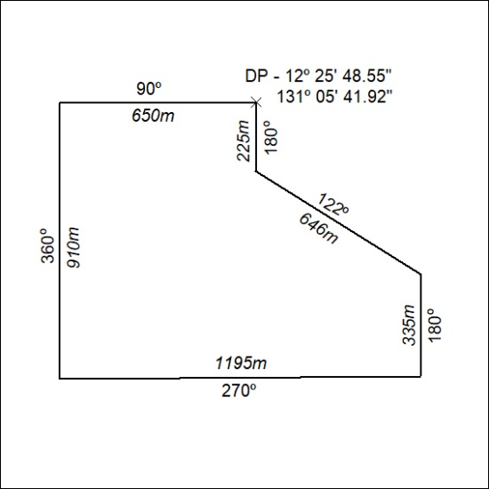

168/22

Mineral Titles Act
NOTICE OF GRANT OF A MINERAL TITLE
Title Type and Number: | Extractive Mineral Permit 32368
Granted: | 19 May 2022, for a period of 5 Years
Area: | 61.80 Hectares
Locality: | KOOLPINYAH
Name of Holder/s: | 100% SAGE CONSTRUCTIONS PTY. LTD. [ACN. 009 654 648]
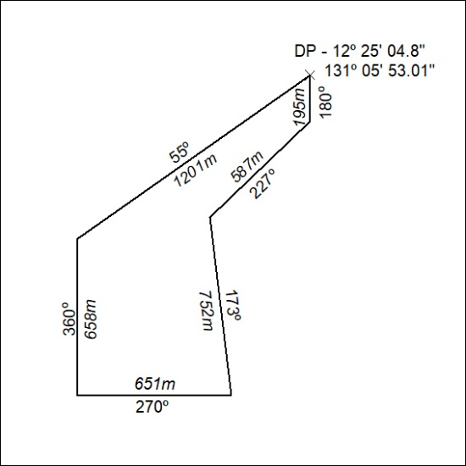

169/22

