Mineral Titles Act 2010
NOTICE OF LAND CEASING TO BE A MINERAL TITLE AREA
Title Type and Number: | Extractive Mineral Permit (Northern) 1315
Area ceased on: | 16 May 2022
Area: | 9.00 Hectare
Locality: | NOONAMAH
Name of Applicants(s)Holder(s): | 100% BOB KERR TRANSPORT PTY LTD [ACN. 109 115 059]
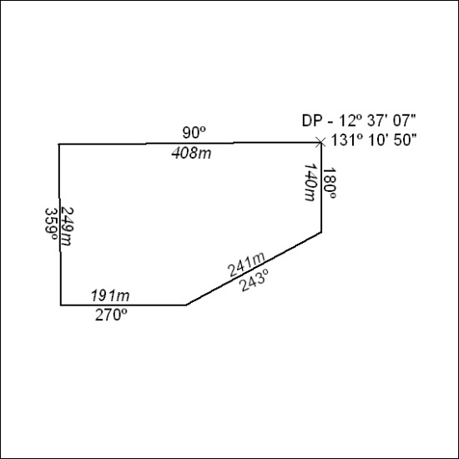

167/22

